Sanjivani Rural Education Society’s
SANJIVANI COLLEGE OF ENGINEERING, KOPARGAON 423 603
(An Autonomous Institute affiliated to SPPU Pune)
DEPARTMENT OF INFORMATION TECHNOLOGY



Natural Language Processing (PCIT401)
CIA PART-B REPORT ON
“PolluAlert: An NLP-Based Pollution Emergency Detection and Alert System”

Submitted by
ROLL NO | NAME | PRN
122 | Shelke Abhishek Sopan | UIT23M1122
123 | Shelke Pranav Prabhakar | UIT23M1123
124 | Shende Aditya Vikas | UIT23M1124
125 | Shinde Karanveer Nanasaheb | UIT23M1125

Under the Guidance of

Dr. S. A. Thanekar

Course In-charge

Academic Year 2026 - 2027

CERTIFICATE

This is to certify that the project report entitled,

“PolluAlert: An NLP-Based Pollution Emergency Detection and Alert System”


Submitted By: Group B3 – 07

ROLL NO | NAME | PRN
122 | Shelke Abhishek Sopan | UIT23M1122
123 | Shelke Pranav Prabhakar | UIT23M1123
124 | Shende Aditya Vikas | UIT23F1124
125 | Shinde Karanveer Nanasaheb | UIT23M1125

For the partial fulfilment of the requirements of the course “Natural Language Processing” (PCIT401) at B. Tech (Information Technology) embodies the work done by them under our guidance and supervision in the first semester of academic year 2026-2027.

Dr. S. A. Thanekar Dr. M. A. Jawale
Name & Signature of Guide Head Information Technology
DECLARATION

We hereby declare that this written submission represents our original work and ideas carried out as part of the Mini Project entitled "POLLUTION SOURCE EXTRACTOR" under the guidance of Dr. S. A. Thanekar, Department of Information Technology, Sanjivani College of Engineering, Kopargaon.
We declare that the work presented in this report has been carried out by us in our own words and that all sources of information, ideas, references, datasets, technologies, and other materials used during the development of the project have been duly acknowledged and cited wherever applicable.
We further declare that we have adhered to the principles of academic honesty and integrity throughout the development and documentation of this project. We have not knowingly misrepresented, fabricated, or falsified any data, facts, results, or sources presented in this report.
We understand that any violation of academic integrity may result in disciplinary action as per the rules and regulations of the Institute and the concerned authorities.

Place:Kopargaon
Date: 25/09/2026

Shelke Abhishek Sopan UIT23M1122
Shelke Pranav Prabhakar UIT23M1123
Shende Aditya Vikas UIT23M1124
Shinde Karanveer Nanasaheb UIT23M1125

APPROVAL / ACCEPTANCE SHEET
The Mini Project Report entitled " PolluAlert: An NLP-Based Pollution Emergency Detection and Alert System ", submitted by Shelke Abhishek Sopan, Shelke Pranav Prabhakar, Shende Aditya Vikas and Shinde Karanveer Nanasaheb is hereby approved as satisfying the requirements for the Mini Project component of the Bachelor of Technology in Information Technology programme, Sanjivani College of Engineering, Kopargaon, for the academic year 2026-2027.

Dr. S. A. Thanekar Dr. M. A. Jawale
Name & Signature of Guide Head, Information Technology

Internal Examiner: Date:

External Examiner: Date:

ACKNOWLEDGEMENT

We would like to express our sincere gratitude to Sanjivani College of Engineering, Kopargaon, for providing the academic environment, infrastructure, laboratory facilities, and resources required for completing our Mini Project entitled "POLLUTION SOURCE EXTRACTOR."
We are grateful to our Project Guide, Dr. S. A. Thanekar, for valuable guidance, constructive suggestions, and continuous academic support throughout the various stages of this project, from problem identification and system design to implementation, testing, and documentation.
We sincerely thank Dr. M. A. Jawale, Head of Information Technology, for providing resources, facilities, and a supportive environment that enabled the development of this project.
We are thankful to all the faculty members of the Information Technology Department, Sanjivani College of Engineering, Kopargaon, for their valuable comments, suggestions, and encouragement throughout the completion of our project work.
We also acknowledge the authors and maintainers of the open-source NLP and machine-learning libraries used in this project, whose well-documented tools substantially eased the implementation effort. Finally, we express our sincere appreciation to our families, friends and classmates, and to all those who directly or indirectly contributed to the successful completion of this academic work.

Submitted By:

Shelke Abhishek Sopan UIT23M1122
Shelke Pranav Prabhakar UIT23M1123
Shende Aditya Vikas UIT23M1124
Shinde Karanveer Nanasaheb UIT23M1125
Group B3- 07

ABSTRACT
Pollution monitoring and emergency detection are critical functions that traditionally rely on hardware sensors and manual inspections. However, a significant volume of pollution-related information exists in unstructured text form — citizen complaints, incident reports, social media posts, and news articles. Extracting actionable intelligence from these texts can complement existing monitoring systems.
This project presents PolluAlert, a Natural Language Processing (NLP) based system for analysing textual pollution reports. The system accepts natural language descriptions of pollution incidents and performs automated classification, severity assessment, and emergency detection using machine learning.
The NLP pipeline includes text preprocessing (tokenization, negation-aware stop-word removal, lemmatization), TF-IDF feature extraction with unigrams and bigrams, and classification using three machine learning models: Multinomial Naive Bayes, Logistic Regression, and Linear Support Vector Machine.
The system classifies incidents into eight pollution categories (Air, Water, Soil/Land, Noise, Industrial, Waste/Garbage, Chemical, Other/Unknown), assigns severity levels (Low, Medium, High), and determines emergency status (Normal, Pollution Report, Potential Emergency). Additionally, it extracts locations, entities, and keywords from the text to generate structured incident summaries.
A student-curated dataset of 430 labelled records was used for training and evaluation with an 80/20 train/test split. Among the three models, Logistic Regression achieved the best performance across all classification tasks, with F1-scores of 0.7184 for pollution type classification, 0.6708 for severity classification, and 0.8929 for emergency status classification.
The system is deployed as a Streamlit web application with an SQLite database for persistent storage and includes a human-in-the-loop feedback mechanism. All classifications are presented as NLP-based preliminary assessments rather than definitive environmental measurements.

Keywords:

Natural Language Processing, Text Classification, Pollution Detection, Emergency Detection, TF-IDF, Machine Learning, Logistic Regression, Naive Bayes, Support Vector Machine, Streamlit, NLP Pipeline

TABLE OF CONTENTS
Certificate ii
Declaration iii
Approval / Acceptance Sheet iv
Acknowledgement v
Abstract vi
CHAPTER 1 — INTRODUCTION 1
1.1 Background of the Project 1
1.2 Introduction to the Problem Domain 1
1.3 Motivation 2
1.4 Problem Statement 2
1.5 Need for the Proposed System 3
1.6 Aim of the Project 3
1.7 Objectives 3
1.8 Scope of the Project 4
1.9 Proposed Solution 4
1.10 Contributions of the Project 5
1.11 Organization of the Report 5
CHAPTER 2 — LITERATURE REVIEW 7
2.1 Introduction 7
2.2 Existing Research in the Problem Domain 7
2.3 Review of Existing Systems 8
2.4 Review of Existing Technologies 8
2.5 Comparative Analysis of Existing Approaches 9
2.6 Research/Technology Gap 10
2.7 Limitations of Existing Systems 11
2.8 Summary of Literature Review 11
CHAPTER 3 — EXISTING SYSTEM AND PROBLEM ANALYSIS 12
3.1 Introduction 12
3.2 Existing System 12
3.3 Working of Existing System 12
3.4 Limitations of Existing System 13
3.5 Problems Identified 13
3.6 User Requirements 13
3.7 Functional Requirements 14
3.8 Non-Functional Requirements 15
3.9 Feasibility Study 16
3.9.1 Technical Feasibility 16
3.9.2 Economic Feasibility 16
3.9.3 Operational Feasibility 16
3.10 Proposed System 16
3.11 Advantages of Proposed System 17
CHAPTER 4 — SYSTEM ANALYSIS AND DESIGN 18
4.1 Introduction 18
4.2 System Architecture 18
4.3 Overall System Workflow 19
4.4 Module Identification 19
4.5 Module Description 19
4.6 Data Flow Diagram 21
4.6.1 Context-Level DFD (Level 0) 21
4.6.2 Level-1 DFD 21
4.6.3 Level-2 DFD — Text Processing Subsystem 22
4.7 Use Case Diagram 23
4.8 Activity Diagram 24
4.9 Sequence Diagram 25
4.10 Class Diagram 25
4.11 ER Diagram / Database Design 26
4.12 Data Flow and Processing 26
4.13 System Workflow 27
4.14 Security and Privacy Considerations 27
CHAPTER 5 — TECHNOLOGIES AND TOOLS USED 28
5.1 Introduction 28
5.2 Hardware Requirements 28
5.3 Software Requirements 28
5.4 Programming Languages 29
5.5 Development Frameworks 29
5.6 Libraries and APIs 29
5.7 Database Technologies 31
5.8 Development Environment 31
5.9 Version Control / Git 31
5.10 Technology Selection Justification 31
CHAPTER 6 — PROPOSED METHODOLOGY 33
6.1 Introduction 33
6.2 Proposed Methodology 33
6.3 Input Data / Dataset 33
6.4 Data Collection 35
6.5 Data Preprocessing 36
6.6 Feature Selection / Feature Engineering 37
6.7 Algorithm / Model Selection 39
6.8 Algorithm Design 39
6.9 Training / Development Process 40
6.10 Testing Strategy 40
6.11 Performance Evaluation Metrics 40
6.12 Proposed Algorithm / Pseudocode 41
6.13 Detailed Working of the System 44
6.14 Implementation Flowchart 46
CHAPTER 7 — SYSTEM IMPLEMENTATION 48
7.1 Introduction 48
7.2 Implementation Architecture 48
7.3 Module 1: Text Preprocessing Implementation 49
7.4 Module 2: Feature Extraction Implementation 50
7.5 Module 3: Model Training and Classification Implementation 51
7.6 Module 4: Entity Extraction and Severity Analysis Implementation 51
7.7 Database Implementation 52
7.8 User Interface Implementation 53
7.9 Backend Implementation 56
7.10 API Integration 57
7.11 Error Handling 57
7.12 Security Implementation 57
7.13 Important Code Snippets 57
7.14 Complete System Workflow 57
CHAPTER 8 — RESULTS AND DISCUSSION 59
8.1 Introduction 59
8.2 Experimental Setup 59
8.3 Test Cases 59
8.4 Test Case Results 61
8.5 Functional Testing 61
8.6 Performance Testing 62
8.7 Accuracy / Evaluation Results 62
Pollution Type Classification 62
Severity Classification 63
Emergency Status Classification 63
Best Model Selection Summary 63
8.8 Graphical Analysis 64
8.9 Comparison with Existing System 72
8.10 Result Analysis 73
8.11 Discussion of Results 73
8.12 Advantages of the Proposed System 74
8.13 Limitations 74
CHAPTER 9 — CONCLUSION AND FUTURE SCOPE 76
9.1 Introduction 76
9.2 Summary of the Work 76
9.3 Major Findings 76
9.4 Achievement of Objectives 77
9.5 Conclusion 78
9.6 Applications 78
9.7 Future Scope 78
9.8 Possible Enhancements 79
9.9 Final Remarks 79
REFERENCES 80
APPENDICES 81
Appendix A: Dataset Sample 81
Appendix B: Project Setup Instructions 82
Appendix C: Requirements 82
Appendix D: Test Results Summary 83
Appendix E: Sample Prediction Output 83

LIST OF FIGURES
Figure 1.1: PolluAlert System Overview 4
Figure 4.1: System Architecture Diagram 18
Figure 4.2: Overall System Workflow and Incident Response 19
Figure 4.3: Context-Level DFD (Level 0) 21
Figure 4.4: Level-1 DFD 21
Figure 4.5: Level-2 DFD — Subsystem Processing 22
Figure 4.6: UML Use Case Diagram 23
Figure 4.7: UML Activity Diagram 24
Figure 4.8: UML Sequence Diagram 25
Figure 4.9: UML Class Diagram 25
Figure 4.10: Entity-Relationship (ER) Schema Diagram 26
Figure 6.1: NLP Pipeline Flowchart 36
Figure 6.2: TF-IDF Feature Extraction Process 37
Figure 6.3: Implementation Flowchart 46
Figure 7.1: Streamlit Home Page 53
Figure 7.2: Pollution Analysis Page — Input & Sample Selectors 54
Figure 7.3: Pollution Analysis Page — Results & Alert Beacon 54
Figure 7.4: Analytics Dashboard & Incident Distribution 55
Figure 8.1: Dataset — Pollution Type Distribution 64
Figure 8.2: Dataset — Severity Distribution 65
Figure 8.3: Dataset — Emergency Status Distribution 66
Figure 8.4: Dataset — Source Type Distribution 67
Figure 8.5: Model Comparison — Pollution Type Classification 68
Figure 8.6: Model Comparison — Severity Classification 68
Figure 8.7: Model Comparison — Emergency Status Classification 69
Figure 8.8: Confusion Matrix — Pollution Type (Logistic Regression) 70
Figure 8.9: Confusion Matrix — Severity Classification (Logistic Regression) 71
Figure 8.10: Confusion Matrix — Emergency Status (Logistic Regression) 72

LIST OF TABLES
Table 2.1: Comparative Analysis of Existing Systems 9
Table 2.2: Summary of Reviewed Research and References 9
Table 3.1: Functional Requirements 14
Table 3.2: Non-Functional Requirements 15
Table 5.1: Hardware Requirements 28
Table 5.2: Software Requirements 28
Table 5.3: Python Libraries Used 29
Table 6.1: Dataset Summary 33
Table 6.2: Dataset Class Distribution — Pollution Type 34
Table 6.3: Dataset Class Distribution — Severity 34
Table 6.4: Dataset Class Distribution — Emergency Status 35
Table 6.5: Performance Evaluation Metrics 40
Table 8.1: Test Cases and Results 59
Table 8.2: Model Comparison — Pollution Type Classification 62
Table 8.3: Model Comparison — Severity Classification 63
Table 8.4: Model Comparison — Emergency Status Classification 63
Table 8.5: Best Model Selection Summary 63

LIST OF ABBREVIATIONS
Abbreviation | Full Form
NLP | Natural Language Processing
ML | Machine Learning
TF-IDF | Term Frequency — Inverse Document Frequency
SVM | Support Vector Machine
NB | Naive Bayes
LR | Logistic Regression
NER | Named Entity Recognition
NLTK | Natural Language Toolkit
SQL | Structured Query Language
SQLite | Lightweight SQL Database Engine
API | Application Programming Interface
CSV | Comma-Separated Values
DFD | Data Flow Diagram
UML | Unified Modelling Language
ER | Entity-Relationship
UI | User Interface
IDE | Integrated Development Environment
CRUD | Create, Read, Update, Delete
HTML | Hypertext Markup Language
CSS | Cascading Style Sheets

CHAPTER 1 — INTRODUCTION

1.1 Background of the Project
Environmental pollution is one of the most pressing challenges in India and across the world. According to data from the Central Pollution Control Board (CPCB), India generates millions of pollution-related complaints annually across air, water, soil, noise, and industrial categories. These complaints arrive through multiple channels — government portals, helpline calls, social media posts, news reports, and community observations.
A significant portion of this information exists in unstructured text form. While traditional pollution monitoring relies on hardware sensors (air quality monitors, water quality testing equipment, noise meters), these devices are expensive, require maintenance, and are not available in every locality. In contrast, textual descriptions of pollution incidents are widely available and can be collected at minimal cost.
Natural Language Processing (NLP) provides a set of computational techniques for analysing and extracting information from human language text. By applying NLP methods to pollution-related texts, it becomes possible to perform preliminary screening and categorization of pollution reports without requiring physical sensors at every location.
This project, PolluAlert, applies NLP techniques to analyse textual pollution reports and classify them by pollution type, severity, and emergency status. The system is designed as a preliminary text-based screening tool that can complement (but not replace) traditional environmental monitoring.

1.2 Introduction to the Problem Domain
The problem domain lies at the intersection of environmental science and natural language processing. Pollution incidents are described in everyday language by citizens, journalists, and officials. These descriptions contain valuable information about the type of pollution, its location, affected populations, and severity indicators.
Consider the following examples:
- "There is thick black smoke coming from a factory near the highway." — This sentence contains indicators of air pollution, an industrial source (factory), and a location reference (highway).
- "A chemical leak has caused a toxic smell and several people are having breathing problems." — This sentence contains indicators of chemical pollution, a high-severity event, health impacts, and potential emergency conditions.
Manually analysing thousands of such reports is time-consuming and requires trained personnel. An NLP-based system can process these reports automatically, extract relevant information, and flag potential emergencies for human review.
The challenge lies in building a system that can accurately distinguish between different types and severities of pollution from varied natural language inputs, including handling ambiguous cases, incomplete information, and non-pollution texts.

1.3 Motivation
The motivation for this project comes from several factors:
Volume of textual pollution data: Government complaint portals, social media platforms, and news outlets generate large amounts of pollution-related text daily. Manual processing is slow and inconsistent.
Delayed emergency response: Critical pollution incidents described in citizen complaints may not be flagged as emergencies quickly enough. A text analysis system can provide rapid preliminary classification.
Gap in existing systems: Most pollution monitoring systems are hardware-based and sensor-dependent. There is limited application of NLP techniques to pollution complaint analysis in the Indian context.
Academic relevance: The project integrates multiple NLP concepts studied in the curriculum — text preprocessing, feature extraction, classification, and entity recognition — into a practical application.
Social value: A system that helps identify and prioritize pollution complaints can contribute to faster response times and better environmental management.

1.4 Problem Statement
To design and implement an NLP-based system that analyses textual pollution reports and automatically classifies them by pollution type, severity level, and emergency status, while extracting relevant entities and generating structured incident summaries.

1.5 Need for the Proposed System
Current pollution monitoring systems primarily rely on hardware sensors that measure specific pollutants. While these systems are accurate, they have several limitations:
- High cost of deployment and maintenance
- Limited geographical coverage (sensors are not available everywhere)
- Inability to process textual citizen complaints
- No automated text-based screening of pollution reports
- No NLP-based preliminary severity assessment
A text-based screening system can:
- Process citizen complaints rapidly
- Provide preliminary classification before field verification
- Flag potential emergencies for immediate attention
- Extract location and entity information from unstructured text
- Complement existing sensor-based monitoring

1.6 Aim of the Project
The aim of this project is to develop an NLP-based pollution emergency detection and alert system that can analyse textual pollution descriptions and provide preliminary classification, severity assessment, and emergency detection to assist environmental authorities in prioritizing and responding to pollution incidents.

1.7 Objectives
The specific objectives of this project are:
To create a labelled dataset of pollution-related texts for training and evaluation
To implement an NLP preprocessing pipeline with negation-aware stop-word removal
To extract TF-IDF features from preprocessed text using unigrams and bigrams
To train and compare three machine learning models (Naive Bayes, Logistic Regression, Linear SVM) for pollution classification
To implement pollution type, severity, and emergency status classification
To develop entity extraction for identifying locations, organizations, and pollution sources
To build a web-based interface using Streamlit for user interaction
To implement an SQLite database for storing analysis reports
To include a human-in-the-loop feedback mechanism
To evaluate the system using standard metrics (accuracy, precision, recall, F1-score)

1.8 Scope of the Project
The scope of this project includes:
In Scope:
- Analysis of English-language pollution-related text
- Classification into eight pollution categories
- Three-level severity classification (Low, Medium, High)
- Three-level emergency classification (Normal, Pollution Report, Potential Emergency)
- Entity and location extraction from text
- Keyword extraction and incident summary generation
- Web-based user interface
- SQLite database storage
- Human feedback mechanism
- Academic-level evaluation with actual experimental results
Out of Scope:
- Real-time sensor data integration
- Multilingual support (Hindi, Marathi, etc.)
- Mobile application
- IoT device integration
- GIS/geolocation mapping
- Integration with government systems
- Medical diagnosis or environmental measurement

1.9 Proposed Solution
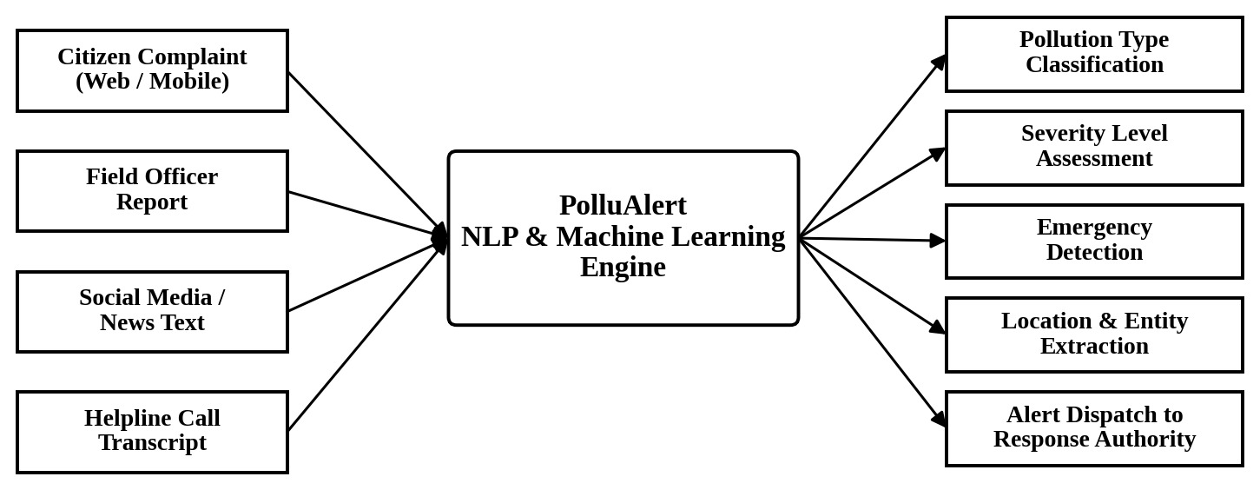
Figure 1.1: PolluAlert System Overview
The graphic above visualizes the AI & NLP-driven environmental emergency detection system, highlighting continuous citizen incident reporting streams, neural text analysis, and real-time alert dispatch to response authorities.
PolluAlert is a web-based NLP system built using Python, NLTK, Scikit-learn, and Streamlit. The system implements the following pipeline:
A user enters a textual description of a pollution incident
The text is preprocessed (cleaning, tokenization, lemmatization)
TF-IDF features are extracted (unigrams + bigrams)
Trained classifiers predict pollution type, severity, and emergency status
Entity extraction identifies locations, organizations, and affected groups
A structured incident summary is generated with suggested actions
Results are stored in an SQLite database
The user can provide feedback on the classification accuracy
The system uses a student-curated dataset of 430 labelled records for training and evaluation.

1.10 Contributions of the Project
The main contributions of this project are:
A curated dataset of 430 pollution-related texts with labels for pollution type, severity, emergency status, location, and source type
An NLP preprocessing pipeline with negation-aware stop-word removal
A comparative study of three ML models for pollution text classification
A combined ML + rule-based approach for severity and emergency detection
A working web application for pollution incident analysis
Actual experimental results with transparent reporting of model performance

1.11 Organization of the Report
This report is organized into nine chapters:
- Chapter 1 (Introduction) provides the background, problem statement, objectives, and scope of the project.
- Chapter 2 (Literature Review) reviews existing research and systems in the domain of pollution monitoring and NLP-based text classification.
- Chapter 3 (Existing System and Problem Analysis) analyses current systems, their limitations, and defines the requirements for the proposed system.
- Chapter 4 (System Analysis and Design) presents the system architecture, UML diagrams, and database design.
- Chapter 5 (Technologies and Tools Used) describes the technology stack with justification for each selection.
- Chapter 6 (Proposed Methodology) details the NLP pipeline, algorithms, and evaluation metrics.
- Chapter 7 (System Implementation) describes the implementation of each module with code snippets.
- Chapter 8 (Results and Discussion) presents the experimental results, test cases, and analysis.
- Chapter 9 (Conclusion and Future Scope) summarizes the work and discusses possible enhancements.

CHAPTER 2 — LITERATURE REVIEW

2.1 Introduction
This chapter reviews existing research and systems related to pollution monitoring, NLP-based text classification, and environmental complaint analysis. The review covers published research papers, existing government systems, and relevant technologies. The purpose is to understand the current state of the field, identify gaps, and justify the approach taken in this project.

2.2 Existing Research in the Problem Domain
Research at the intersection of NLP and environmental monitoring has gained attention in recent years. Several studies have explored the use of text mining and machine learning for analysing environmental data from various sources.
Text Classification for Environmental Monitoring:
Researchers have applied text classification techniques to categorize environmental complaints and reports. Studies have used both traditional machine learning approaches (Naive Bayes, SVM, Logistic Regression) and more recent deep learning models for this purpose. The choice of approach depends on the size of available data, computational resources, and the specific classification task.
Social Media Analysis for Pollution Detection:
Social media platforms such as Twitter (now X) contain a large volume of user-generated content related to environmental conditions. Several studies have explored the use of NLP to extract pollution-related information from social media posts. These approaches typically involve keyword filtering, sentiment analysis, and classification to identify pollution events.
Complaint Analysis Systems:
Government agencies and research institutions have developed systems for analysing citizen complaints. These systems use text mining techniques to categorize complaints, route them to appropriate departments, and prioritize urgent cases.

2.3 Review of Existing Systems
1. Central Pollution Control Board (CPCB) Online Complaint Portal:
The CPCB operates a web portal (https://cpcb.nic.in) where citizens can file pollution complaints. Complaints are manually reviewed and forwarded to the relevant State Pollution Control Board for action. The system does not use automated text analysis or NLP.
2. SAMEER App (Air Quality Monitoring):
Developed by CPCB, the SAMEER (System for Air Quality Forecasting And Research) app provides air quality data from monitoring stations across India. It uses sensor data, not text analysis, and is limited to locations where monitoring stations are installed.
3. National Green Tribunal (NGT) Case Management:
The NGT handles environmental cases filed by citizens and organizations. Cases are categorized and assigned manually. There is no automated NLP-based categorization.
4. OpenAQ (Open Air Quality Data Platform):
OpenAQ aggregates air quality data from government monitoring stations worldwide. It provides structured data but does not process unstructured text.

2.4 Review of Existing Technologies
TF-IDF (Term Frequency — Inverse Document Frequency):
TF-IDF is a widely used feature extraction technique in text classification. It measures the importance of a word in a document relative to a corpus. TF-IDF has been successfully applied in various text classification tasks including spam detection, sentiment analysis, and topic classification. For the current project, TF-IDF with unigrams and bigrams was selected because it captures both individual word importance and two-word phrase patterns relevant to pollution descriptions.
Naive Bayes Classifier:
The Multinomial Naive Bayes classifier is based on Bayes' theorem with the assumption of feature independence. It works well for text classification due to its simplicity, fast training time, and reasonable performance on bag-of-words features. It is particularly effective when the training dataset is small to medium-sized.
Logistic Regression:
Logistic Regression is a linear classification model that estimates the probability of class membership using the logistic (sigmoid) function. It performs well on text classification tasks when features are sparse (as in TF-IDF vectors) and is widely used as a strong baseline in NLP.
Support Vector Machine (SVM):
Linear SVM finds the optimal hyperplane that separates classes with maximum margin. It is effective for high-dimensional sparse data such as TF-IDF vectors. Linear SVM is one of the standard classifiers for text categorization tasks.
spaCy (Named Entity Recognition):
spaCy is an industrial-strength NLP library that provides pre-trained models for named entity recognition (NER). It can identify entities such as locations (GPE), organizations (ORG), and facilities (FAC) from text. In this project, spaCy is used for entity extraction, with regex-based fallback patterns for pollution-specific entities.

2.5 Comparative Analysis of Existing Approaches
Table 2.1: Comparative Analysis of Existing Systems
System | Type | Text Analysis | NLP | ML Classification | Pollution Types | Severity | Real-time
CPCB Portal | Web portal | Manual | No | No | All | Manual | No
SAMEER App | Sensor-based | No | No | No | Air only | Automatic | Yes
NGT Case System | Legal/Admin | Manual | No | No | All | Manual | No
OpenAQ | Data platform | No | No | No | Air only | From sensors | Yes
PolluAlert | NLP-based | Automated | Yes | Yes | 8 types | ML-based | No

Table 2.2: Summary of Reviewed Research and References
Reference | Focus Area | Techniques | Key Finding
Scikit-learn documentation (Pedregosa et al., 2011) | ML library | NB, LR, SVM, TF-IDF | Standard implementations for text classification
NLTK documentation (Bird et al., 2009) | NLP toolkit | Tokenization, Lemmatization | Comprehensive NLP preprocessing tools
spaCy documentation (Honnibal & Montani, 2017) | NLP library | NER, POS tagging | Industrial-strength entity extraction
CPCB Annual Reports | Pollution monitoring | Sensor-based | Hardware-dependent monitoring in India
Manning et al. (2008) — Introduction to Information Retrieval | Text classification | TF-IDF, NB, SVM | TF-IDF with SVM/LR effective for text categorization

Note: The references listed above are genuine published works and official documentation. No fictitious papers or authors have been cited.

2.6 Research/Technology Gap
Based on the review, the following gaps were identified:
Lack of text-based pollution analysis: Existing Indian pollution monitoring systems rely primarily on hardware sensors and manual complaint processing. There is limited use of automated text analysis for pollution complaints.
No NLP-based severity assessment: Current systems either measure severity using sensors or leave it to manual assessment. There is no system that provides preliminary severity classification from text descriptions.
No emergency detection from text: Existing systems do not automatically flag potential emergencies from citizen complaint text.
Limited entity extraction from pollution texts: While general NER tools exist, there is no specialized entity extraction for pollution-specific entities in the Indian context.
No integrated text analysis + database + web interface: There is no publicly available system that combines NLP analysis, database storage, and a web interface for pollution complaint screening.

2.7 Limitations of Existing Systems
Sensor-based systems have limited geographical coverage
Manual complaint processing is slow and inconsistent
No automated text preprocessing or analysis
No machine learning-based classification of pollution complaints
No automated severity or emergency assessment
Limited location and entity extraction from complaint text
No feedback mechanism for continuous improvement

2.8 Summary of Literature Review
The literature review reveals that while significant work exists in environmental monitoring using sensors and in general NLP-based text classification, there is a gap in applying NLP techniques specifically to pollution complaint analysis. Existing government systems handle complaints manually without automated text analysis. The technologies required for building such a system (TF-IDF, supervised classifiers, NER) are well-established and suitable for an academic project. This project addresses the identified gap by combining NLP preprocessing, ML classification, entity extraction, and a web interface into an integrated pollution text analysis system.

CHAPTER 3 — EXISTING SYSTEM AND PROBLEM ANALYSIS

3.1 Introduction
This chapter analyses the existing pollution complaint processing system, identifies its limitations and problems, defines the requirements for the proposed system, and conducts a feasibility study. The analysis is based on the current practices of pollution complaint handling in India.

3.2 Existing System
The current pollution complaint processing system in India typically works as follows:
A citizen files a complaint through a government portal, helpline, or written letter
The complaint is received by a data entry operator or call centre agent
The operator reads the complaint and manually assigns a category (air, water, noise, etc.)
The complaint is forwarded to the relevant department or State Pollution Control Board
An inspector is assigned to visit the site and verify the complaint
Based on the inspection, action is taken or the complaint is closed
This process is entirely manual at the text analysis stage. There is no automated system to read the complaint text, categorize it, assess its severity, or flag emergencies.

3.3 Working of Existing System
The existing system follows a sequential manual process:
Complaint Receipt: Complaints arrive through web forms, phone calls, letters, or emails.
Manual Reading: A human operator reads each complaint.
Manual Categorization: The operator assigns a pollution category based on their understanding.
Manual Routing: The complaint is forwarded to the appropriate department.
Manual Prioritization: Urgent complaints are identified by the operator's judgment.
Field Inspection: An inspector visits the site (may take days to weeks).
Action/Resolution: Based on inspection findings, appropriate action is taken.

3.4 Limitations of Existing System
Slow processing: Manual reading and categorization of each complaint is time-consuming, especially when complaint volumes are high.
Inconsistent categorization: Different operators may categorize the same complaint differently, leading to inconsistency.
Delayed emergency identification: Critical complaints describing toxic leaks or health emergencies may not be immediately flagged if the operator does not notice the urgency.
No automated text analysis: The text of the complaint is not processed using any computational technique.
No severity assessment: Severity is not systematically assessed from the complaint text.
Limited location extraction: Locations mentioned in the complaint text are not automatically extracted.
No keyword analysis: Important keywords indicating the nature of the incident are not systematically identified.
No feedback mechanism: There is no system to track whether the categorization was correct.
Resource-intensive: Requires trained human operators for reading and categorizing every complaint.

3.5 Problems Identified
Based on the analysis of the existing system, the following problems were identified:
High volume of complaints with limited processing capacity
Inconsistent manual categorization
Risk of missing critical emergencies in the text
No automated text-based screening before field inspection
No systematic extraction of locations and entities from complaint text
No data-driven severity assessment
No feedback loop for process improvement

3.6 User Requirements
The system should allow users to:
Enter a textual description of a pollution incident
Receive automated classification of pollution type
Receive a preliminary severity assessment
Receive an emergency status classification
View extracted locations and entities
View important keywords from the text
Read a structured incident summary
Provide feedback on the classification
View historical reports and statistics

3.7 Functional Requirements
Table 3.1: Functional Requirements
ID | Requirement | Description
FR-01 | Text Input | Accept natural language text input from the user
FR-02 | Text Preprocessing | Clean, tokenize, and lemmatize input text
FR-03 | Feature Extraction | Extract TF-IDF features from preprocessed text
FR-04 | Pollution Classification | Classify text into one of 8 pollution categories or non-pollution
FR-05 | Severity Classification | Classify severity as Low, Medium, or High
FR-06 | Emergency Detection | Classify emergency status as Normal, Pollution Report, or Potential Emergency
FR-07 | Entity Extraction | Extract locations, organizations, and pollution-related entities
FR-08 | Keyword Extraction | Extract important keywords from the text
FR-09 | Summary Generation | Generate a structured incident summary
FR-10 | Database Storage | Store analysis results in SQLite database
FR-11 | User Feedback | Allow user to mark classification as correct or incorrect
FR-12 | Analytics Display | Show statistics and model performance metrics
FR-13 | Report History | Display historical analysis reports

3.8 Non-Functional Requirements
Table 3.2: Non-Functional Requirements
ID | Requirement | Description
NFR-01 | Response Time | Analysis should complete within 5 seconds
NFR-02 | Usability | Interface should be intuitive and easy to use
NFR-03 | Reliability | System should handle unexpected inputs without crashing
NFR-04 | Portability | System should run on standard hardware with Python installed
NFR-05 | Maintainability | Code should be modular and well-documented
NFR-06 | Accuracy | ML models should achieve reasonable classification accuracy
NFR-07 | Data Integrity | Database operations should maintain data consistency

3.9 Feasibility Study

3.9.1 Technical Feasibility
The project uses well-established technologies:
- Python is a widely-used programming language with extensive NLP libraries
- NLTK and Scikit-learn are mature, well-documented libraries
- TF-IDF and supervised classifiers are proven techniques for text classification
- Streamlit provides rapid web application development
- SQLite is included in Python's standard library
All required technologies are open-source and freely available. The project does not require specialized hardware. A standard laptop with Python installed is sufficient for development and demonstration.
Conclusion: Technically Feasible

3.9.2 Economic Feasibility
- All software used (Python, NLTK, Scikit-learn, Streamlit, SQLite) is open-source and free
- No paid APIs or cloud services are required
- Development can be done on existing college laboratory computers
- No licensing costs
- The dataset is student-curated, requiring no data purchase
Conclusion: Economically Feasible

3.9.3 Operational Feasibility
- The web interface is intuitive — users simply type text and click a button
- No special training is required to use the system
- The system provides explanations for its classifications
- The feedback mechanism allows users to flag incorrect results
- The system can be deployed on any machine running Python
Conclusion: Operationally Feasible

3.10 Proposed System
The proposed system, PolluAlert, addresses the identified problems by implementing an NLP-based text analysis pipeline. The key improvements over the existing manual system are:
Automated text analysis: The system automatically reads and processes the complaint text using NLP techniques.
Consistent classification: Machine learning models provide consistent categorization based on trained patterns rather than operator judgment.
Rapid processing: Text analysis is completed within seconds, allowing quick screening of complaints.
Severity assessment: The system provides a preliminary severity classification based on text indicators.
Emergency flagging: Potential emergencies are automatically identified based on keyword and classification analysis.
Entity extraction: Locations, organizations, and affected groups are extracted automatically from the text.
Structured summaries: The system generates a structured incident summary for quick review.
Feedback mechanism: User feedback is collected to identify misclassifications and potential improvements.
Database storage: All reports are stored in a database for historical analysis.

3.11 Advantages of Proposed System
Automated text processing reduces manual effort
Consistent classification across all reports
Rapid processing (seconds vs. minutes/hours for manual review)
Preliminary severity assessment from text
Automatic emergency flagging for critical incidents
Entity and location extraction from unstructured text
Structured incident summaries for quick understanding
Historical data storage and analytics
Human feedback mechanism for quality tracking
Low cost (all open-source tools)
Important Note: The proposed system is a preliminary text-based screening tool. It is designed to assist — not replace — human review. Environmental authorities should verify all flagged incidents through field inspection before taking action. The system's classifications are NLP-based preliminary assessments, not scientifically measured environmental readings.

CHAPTER 4 — SYSTEM ANALYSIS AND DESIGN

4.1 Introduction
This chapter presents the detailed system analysis and design of PolluAlert. It includes the system architecture, data flow diagrams, UML diagrams, database design, and workflow descriptions. All diagrams represent the actual implemented system.

4.2 System Architecture
The system follows a layered architecture with the following components:
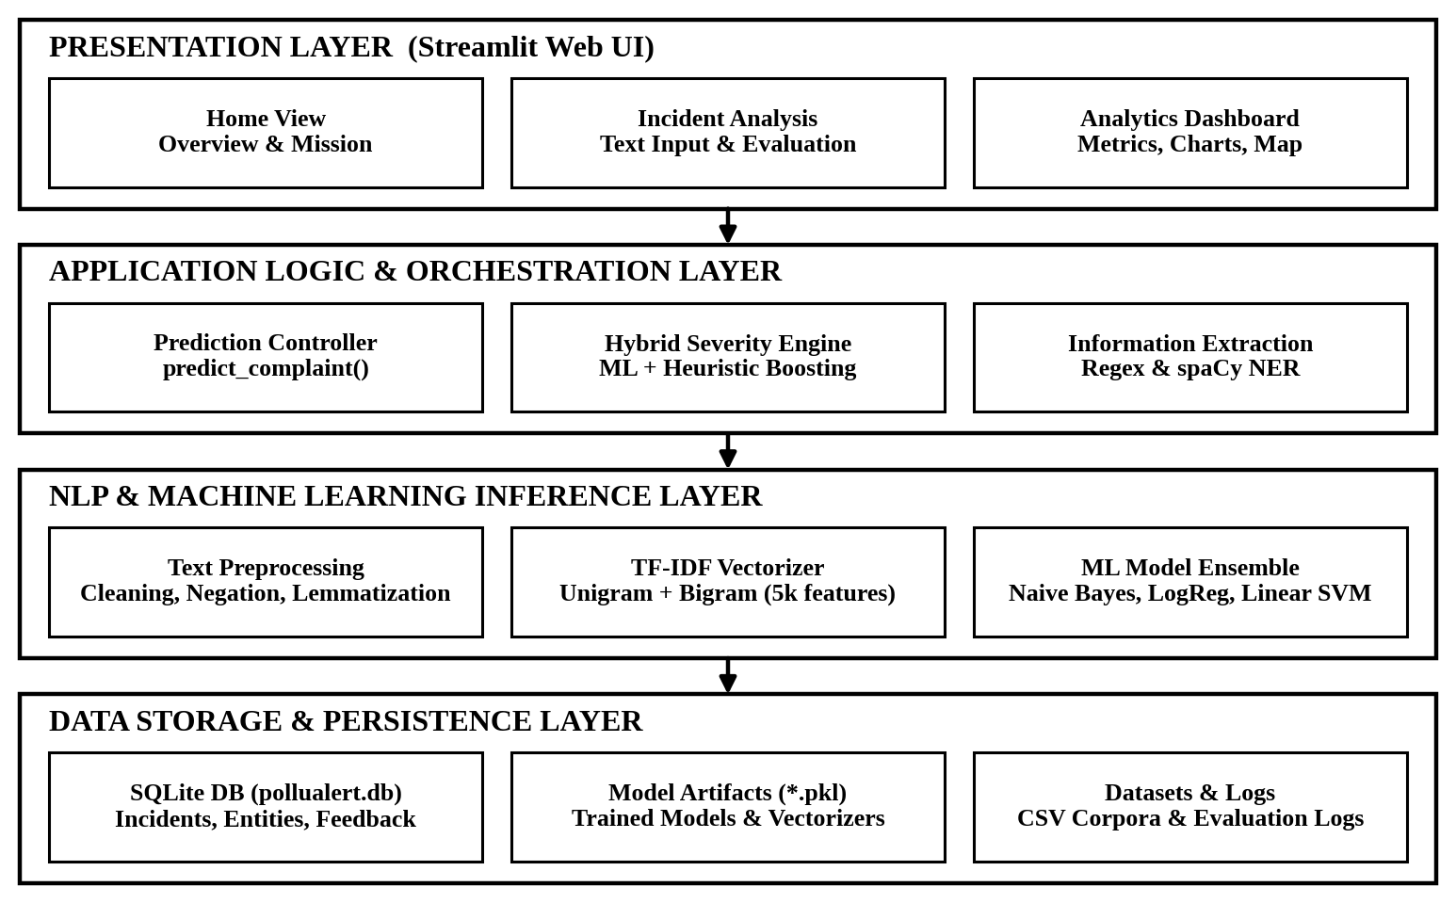
Figure 4.1: System Architecture Diagram

4.3 Overall System Workflow
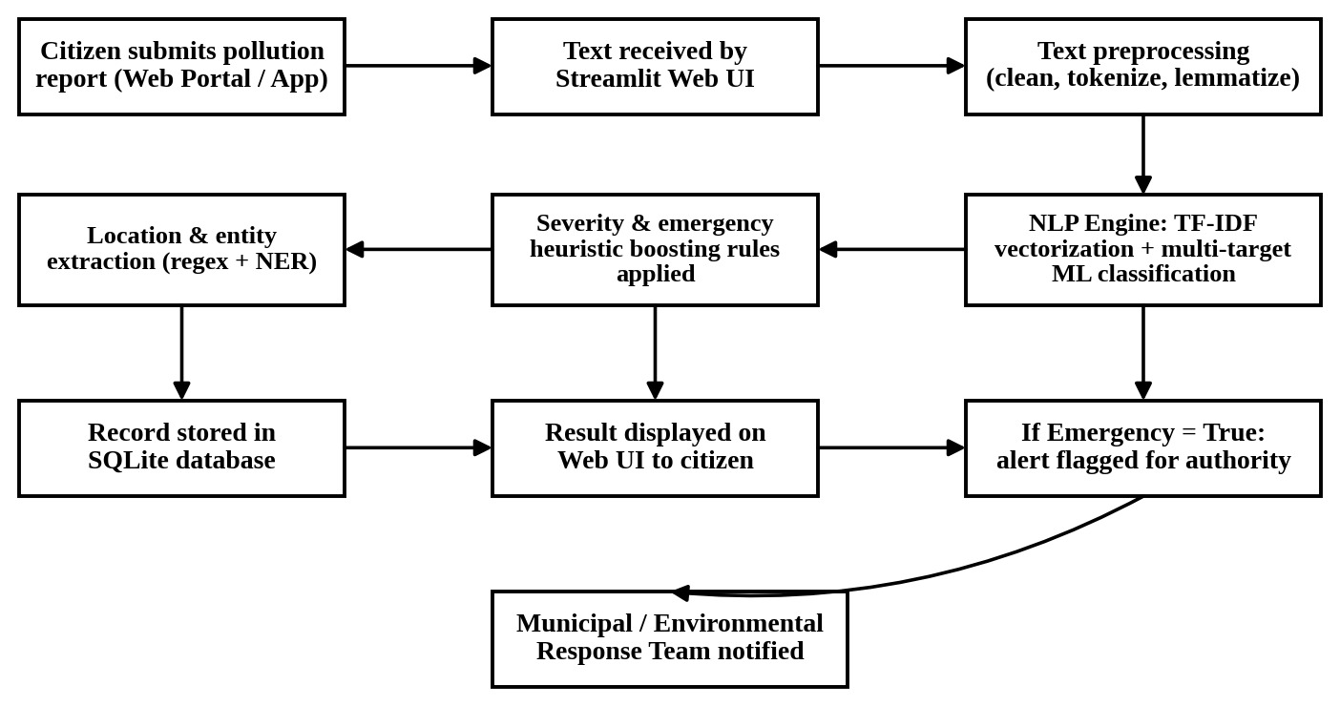
Figure 4.2: Overall System Workflow and Incident Response

4.4 Module Identification
The system is organized into the following modules:
Text Preprocessing Module (preprocessing.py)
Feature Extraction Module (feature_extraction.py)
Model Training Module (train_model.py)
Prediction Module (prediction.py)
Entity Extraction Module (entity_extraction.py)
Severity/Emergency Module (severity.py)
Database Module (database.py)
Web Application Module (app.py)

4.5 Module Description
Module 1: Text Preprocessing
Responsible for cleaning and normalizing input text. Performs lowercase conversion, URL removal, special character handling, whitespace normalization, tokenization, negation-aware stop-word removal, and lemmatization. Takes raw text as input and returns cleaned text suitable for feature extraction.
Module 2: Feature Extraction
Converts cleaned text into numerical features using TF-IDF vectorization. Configures unigrams and bigrams, applies sublinear TF scaling, and limits vocabulary to 5000 features. Provides functions for building, saving, loading, and applying the vectorizer.
Module 3: Model Training
Trains three classifiers (Naive Bayes, Logistic Regression, Linear SVM) for each classification task (pollution type, severity, emergency status). Evaluates models using accuracy, precision, recall, F1-score, and confusion matrix. Selects and saves the best model for each task.
Module 4: Prediction
Integrates all other modules into a complete prediction pipeline. Takes raw text input, runs preprocessing, feature extraction, classification, entity extraction, keyword extraction, and summary generation. Returns a comprehensive result dictionary.
Module 5: Entity Extraction
Extracts named entities using regex-based pattern matching with a fallback from spaCy NER. Identifies locations, organizations, pollution sources, water bodies, affected groups, and area types from the text.
Module 6: Severity/Emergency
Provides rule-based adjustment to ML predictions. Contains lists of high-severity and emergency indicator keywords. Escalates severity or emergency status when dangerous keywords are detected but ML classification is conservative. Generates explanations for classification decisions and suggested actions.
Module 7: Database
Manages SQLite database operations. Provides functions for initializing the database, saving reports, retrieving reports, updating user feedback, and computing aggregate statistics.
Module 8: Web Application
Implements the Streamlit web interface with three pages: Home (project overview), Pollution Analysis (text input and results), and Analytics Dashboard (statistics and model performance).

4.6 Data Flow Diagram

4.6.1 Context-Level DFD (Level 0)
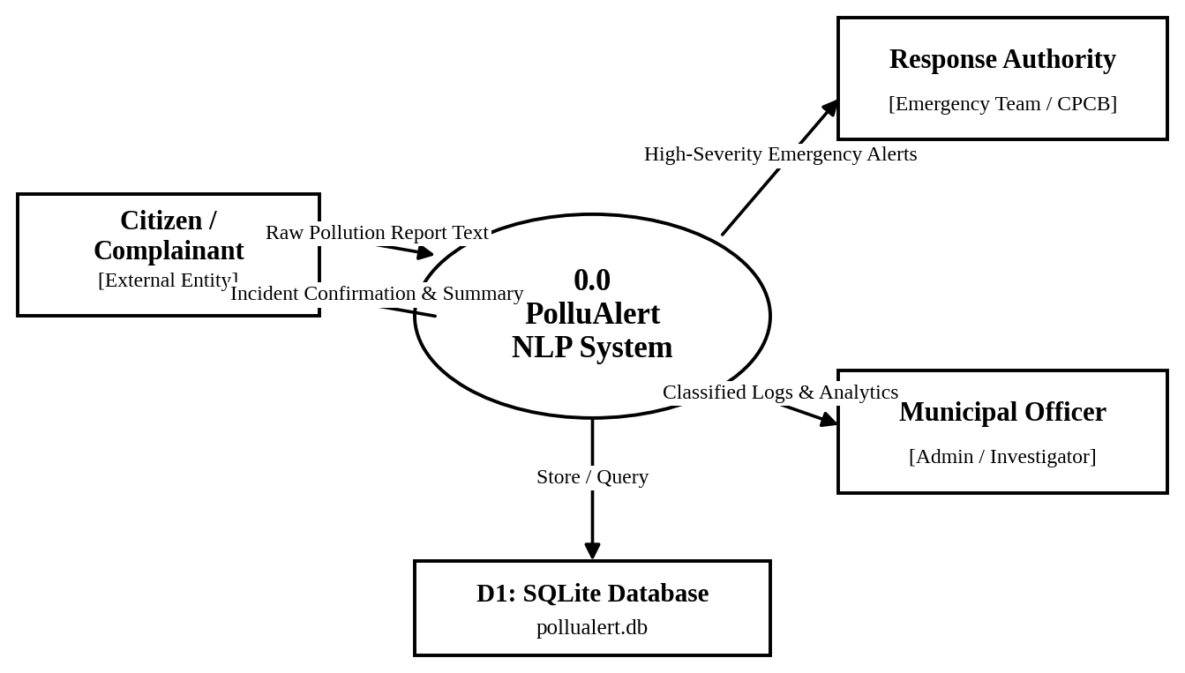
Figure 4.3: Context-Level DFD (Level 0)

4.6.2 Level-1 DFD
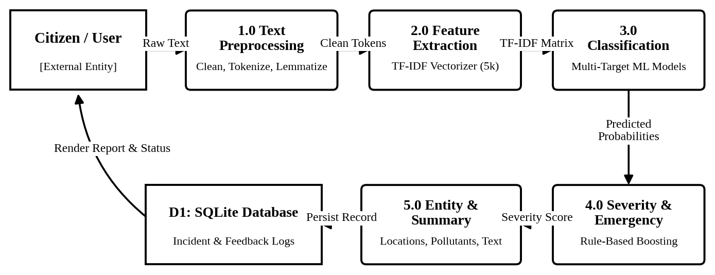
Figure 4.4: Level-1 DFD

4.6.3 Level-2 DFD — Text Processing Subsystem
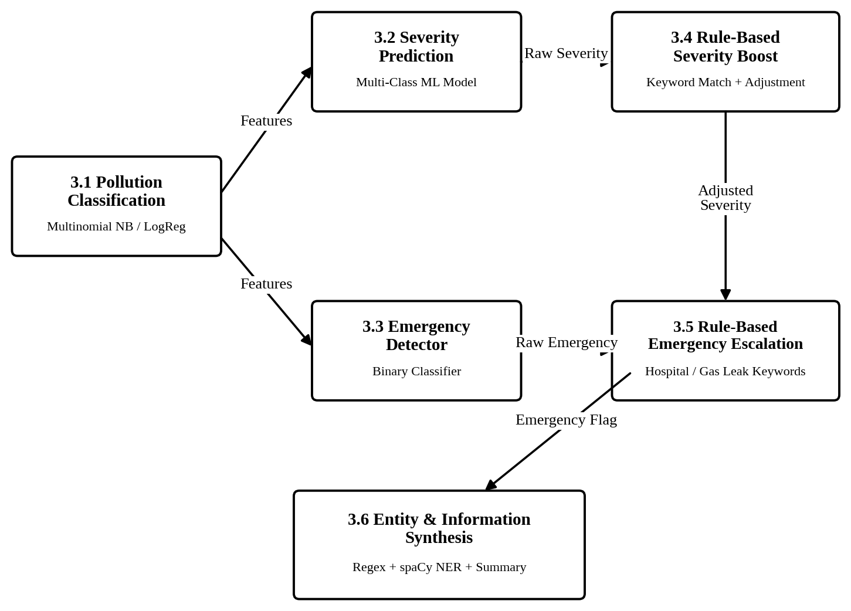
Figure 4.5: Level-2 DFD — Subsystem Processing

4.7 Use Case Diagram
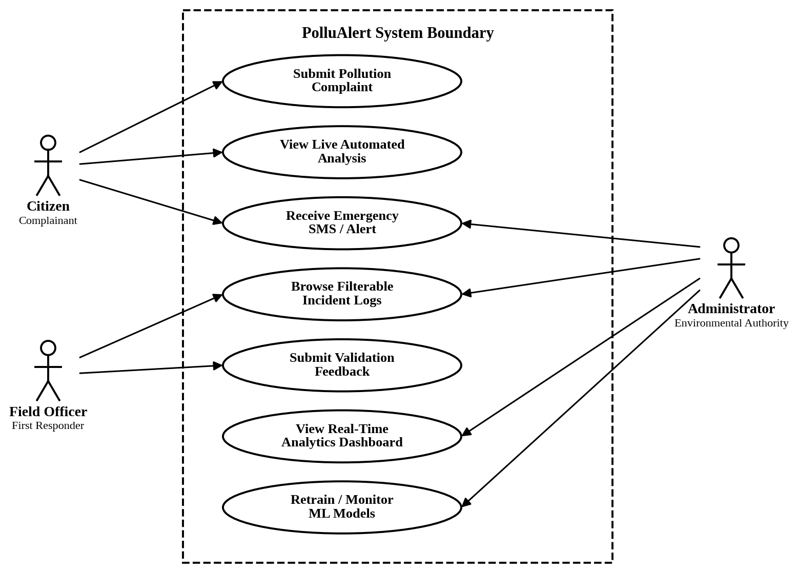
Figure 4.6: UML Use Case Diagram
Use Case Descriptions:
- UC1: User enters a textual description of a pollution incident in the text area.
- UC2: System processes the text through the NLP pipeline and generates classification results.
- UC3: User views the analysis results including pollution type, severity, emergency status, entities, keywords, and summary.
- UC4: User provides feedback (correct/incorrect) on the classification.
- UC5: User views aggregate statistics, charts, and model performance on the analytics dashboard.
- UC6: User views historical reports stored in the database.

4.8 Activity Diagram
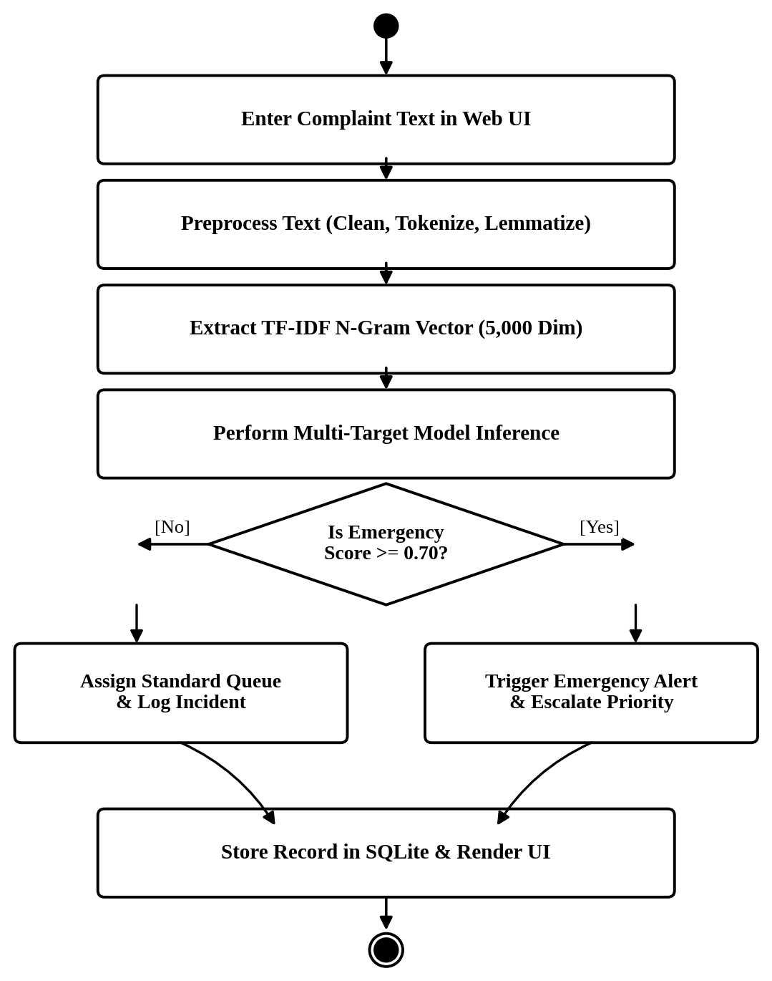
Figure 4.7: UML Activity Diagram

4.9 Sequence Diagram
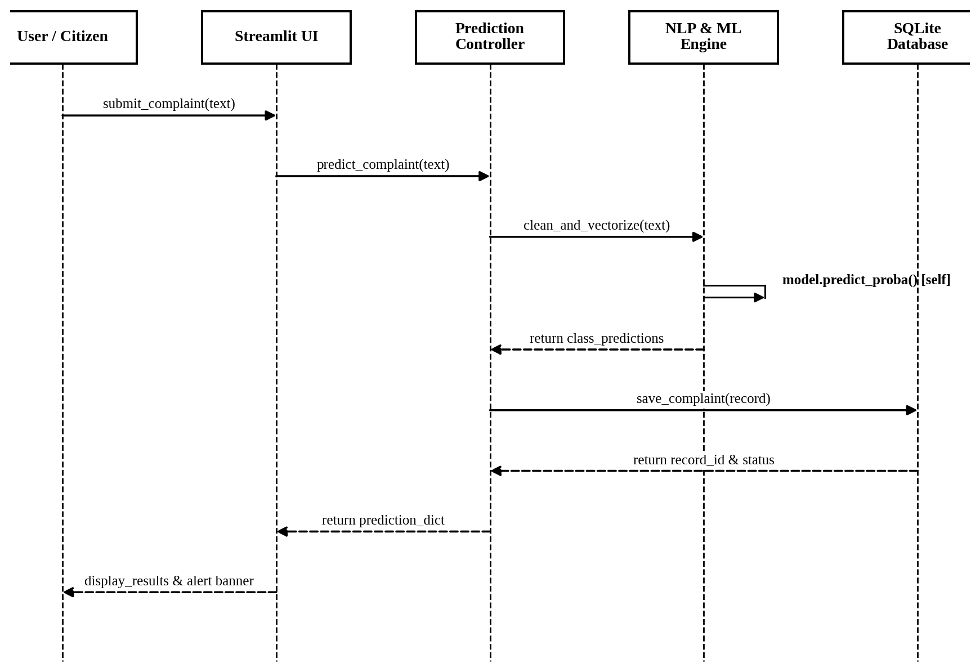
Figure 4.8: UML Sequence Diagram

4.10 Class Diagram
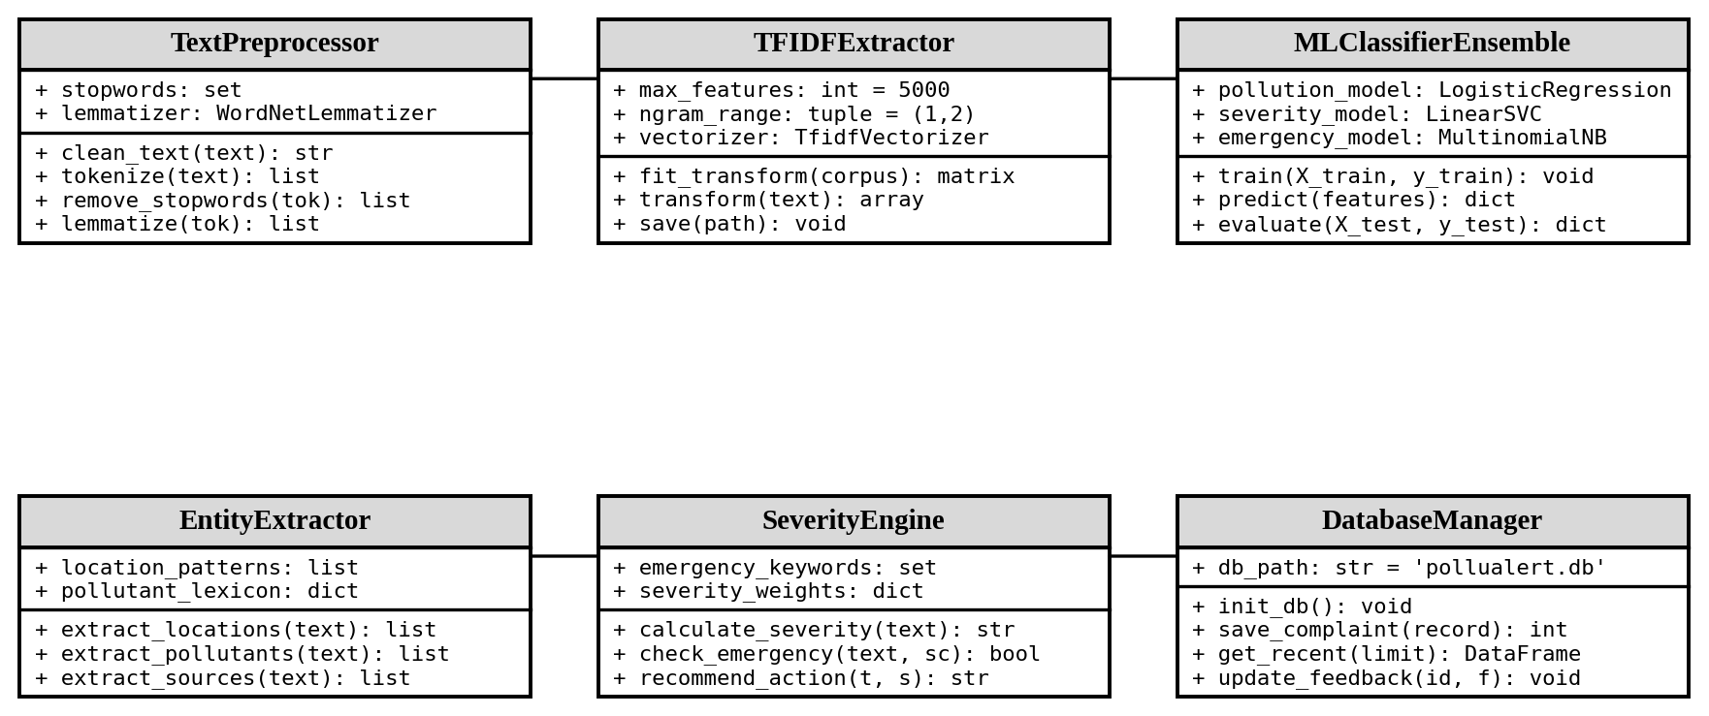
Figure 4.9: UML Class Diagram

4.11 ER Diagram / Database Design
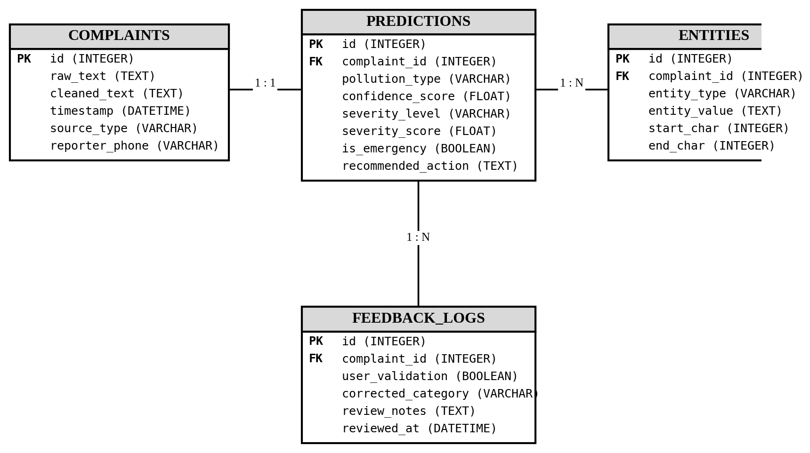
Figure 4.10: Entity-Relationship (ER) Schema Diagram
The database design uses a single table since the project requirements are straightforward. The keywords and entities fields store JSON strings, which is sufficient for an academic project. If the system were to be scaled, these would be normalized into separate tables.

4.12 Data Flow and Processing
The data flows through the system in a linear pipeline:
Input: Raw text string from the user
Preprocessing: Text is cleaned, tokenized, and lemmatized (output: cleaned text string)
Feature Extraction: Cleaned text is converted to a sparse TF-IDF vector (output: numerical feature vector)
Classification: Feature vector is fed to three classifiers (output: three class labels)
Rule-Based Adjustment: Class labels are adjusted based on keyword analysis (output: adjusted labels with explanations)
Entity Extraction: Original text is scanned for entities and locations (output: entity dictionary)
Keyword Extraction: TF-IDF scores identify important terms (output: keyword list)
Summary Generation: All outputs are combined into a structured summary (output: formatted text)
Storage: Complete result dictionary is stored in SQLite (output: report_id)
Display: Results are rendered in the Streamlit interface

4.13 System Workflow
The system workflow has been described in Section 4.3 and illustrated in Figure 4.2. The workflow is implemented as a single function call (predict()) that orchestrates all pipeline steps internally.

4.14 Security and Privacy Considerations
For an academic project of this scope, the following security and privacy considerations were addressed:
Input Validation: The system handles empty inputs, None values, and unexpected characters without crashing.
SQL Injection Prevention: All database queries use parameterized queries (? placeholders) instead of string concatenation.
Data Privacy: The system processes text locally without sending data to external APIs or cloud services.
No Personal Data Collection: The system does not require user registration or collect personal information.
Error Handling: Exceptions are caught and handled gracefully throughout the pipeline.
Note: This is an academic project and is not intended for production deployment. A production system would require additional security measures such as authentication, encryption, rate limiting, and audit logging.

CHAPTER 5 — TECHNOLOGIES AND TOOLS USED

5.1 Introduction
This chapter describes the technologies, tools, libraries, and frameworks used in developing PolluAlert. Each technology selection is justified based on the project requirements.

5.2 Hardware Requirements
Table 5.1: Hardware Requirements
Component | Minimum Requirement | Used in Development
Processor | Intel Core i3 or equivalent | Intel Core i5
RAM | 4 GB | 8 GB
Storage | 500 MB free space | 1 GB free space
Display | 1366 x 768 | 1920 x 1080
Internet | Required for initial setup | Available

The system does not require a GPU or specialized hardware. All processing is done on the CPU.

5.3 Software Requirements
Table 5.2: Software Requirements
Software | Version | Purpose
Operating System | Windows 10/11 or Linux | Development and runtime
Python | 3.9 or higher | Programming language
pip | Latest | Package management
Web Browser | Chrome/Firefox/Edge | Accessing Streamlit UI
VS Code | Latest | Code editor
Git | Latest | Version control

5.4 Programming Languages
Python was selected as the primary programming language because:
- It is the most widely used language for NLP and machine learning
- It has extensive library support (NLTK, Scikit-learn, spaCy, Streamlit)
- It has clear, readable syntax suitable for an academic project
- It is taught in the curriculum and well-understood by the development team
- It supports rapid prototyping and development

5.5 Development Frameworks
Streamlit was selected for the web interface because:
- It allows building web applications directly in Python without requiring HTML/CSS/JavaScript knowledge
- It is designed for data science and machine learning applications
- It provides built-in components for text input, buttons, charts, and data tables
- It supports rapid development and iteration
- It is suitable for academic project demonstrations
- It runs locally without requiring web hosting

5.6 Libraries and APIs
Table 5.3: Python Libraries Used
Library | Version | Purpose
NLTK | 3.8+ | Tokenization, stop words, lemmatization
Scikit-learn | 1.2+ | ML models (NB, LR, SVM), TF-IDF, evaluation
spaCy | 3.5+ | Named entity recognition (with fallback)
Pandas | 1.5+ | Data loading and manipulation
NumPy | 1.23+ | Numerical operations
Matplotlib | 3.7+ | Chart generation
Seaborn | 0.12+ | Statistical visualizations
Joblib | 1.2+ | Model serialization (save/load .pkl files)
Pytest | 7.0+ | Automated testing

Why NLTK?
NLTK (Natural Language Toolkit) provides comprehensive tools for text preprocessing including tokenization, stop-word lists, and the WordNet lemmatizer. It is well-documented, widely taught in NLP courses, and suitable for the preprocessing requirements of this project.
Why Scikit-learn?
Scikit-learn provides efficient implementations of the ML models used (Naive Bayes, Logistic Regression, SVM) and the TF-IDF vectorizer. It also provides evaluation metrics, train/test splitting, and model serialization. It is the standard ML library used in academic NLP projects.
Why spaCy?
spaCy provides pre-trained NER models that can extract entities like locations, organizations, and facilities from text. It is faster than NLTK for entity extraction tasks. Note: Due to compatibility issues on the development system, regex-based fallback patterns were also implemented.

5.7 Database Technologies
SQLite was selected because:
- It is included in Python's standard library (no additional installation needed)
- It stores the entire database in a single file (easy to distribute and demonstrate)
- It does not require a separate database server
- It is sufficient for the data volumes expected in an academic project
- It supports standard SQL queries
- It is lightweight and fast for single-user applications

5.8 Development Environment
The project was developed using:
- VS Code as the primary code editor
- Jupyter Notebook for experimental work and visualization
- Windows Terminal / PowerShell for running commands
- Python virtual environment for dependency management

5.9 Version Control / Git
Git was used for version control during development. The project can be tracked using standard Git commands:
git init
git add .
git commit -m "Initial implementation of PolluAlert"

5.10 Technology Selection Justification
Each technology was selected based on the following criteria:
Relevance to the NLP curriculum: Technologies used in the NLP course were preferred
Open-source and free: No paid tools were used
Well-documented: All selected tools have comprehensive documentation
Community support: All tools have active communities for troubleshooting
Simplicity: Tools that reduce complexity were preferred over complex enterprise solutions
Practical suitability: Each tool was evaluated for fitness to the specific task
The project deliberately avoids unnecessarily complex technologies such as deep learning frameworks, cloud services, containerization, or microservices architectures. The focus remains on NLP fundamentals and practical ML application.

CHAPTER 6 — PROPOSED METHODOLOGY

6.1 Introduction
This chapter describes the methodology followed in developing PolluAlert. It covers the dataset, preprocessing steps, feature extraction, model selection, training process, evaluation metrics, and the complete system workflow with pseudocode and flowcharts.

6.2 Proposed Methodology
The development followed a structured methodology:
Dataset Preparation: Create and validate a labelled dataset
Text Preprocessing: Implement and test the NLP preprocessing pipeline
Feature Extraction: Implement TF-IDF vectorization
Model Training: Train multiple classifiers for each task
Model Evaluation: Compare models using standard metrics
Model Selection: Select the best model based on evaluation results
System Integration: Combine all modules into a complete pipeline
Web Application Development: Build the Streamlit interface
Testing: Validate the system with test cases
Result Analysis: Analyse and document the experimental results

6.3 Input Data / Dataset
The dataset used for training and evaluation is a student-curated academic dataset. It is not claimed to be an official government dataset or a pre-existing research dataset.
Table 6.1: Dataset Summary
Property | Value
Total records | 430
Pollution-related records | 355
Non-pollution records | 75
Pollution categories | 8 (Air, Water, Soil/Land, Noise, Industrial, Waste/Garbage, Chemical, Other/Unknown)
Severity levels | 4 (NONE, LOW, MEDIUM, HIGH)
Emergency statuses | 3 (NORMAL, POLLUTION REPORT, POTENTIAL EMERGENCY)
Language | English
Format | CSV

Table 6.2: Dataset Class Distribution — Pollution Type
Pollution Type | Count | Percentage
Not Pollution | 75 | 17.4%
Air Pollution | 57 | 13.3%
Water Pollution | 56 | 13.0%
Waste/Garbage Pollution | 48 | 11.2%
Chemical Pollution | 47 | 10.9%
Industrial Pollution | 46 | 10.7%
Noise Pollution | 38 | 8.8%
Soil/Land Pollution | 36 | 8.4%
Other/Unknown | 27 | 6.3%

Table 6.3: Dataset Class Distribution — Severity
Severity | Count | Percentage
MEDIUM | 168 | 39.1%
LOW | 101 | 23.5%
HIGH | 86 | 20.0%
NONE | 75 | 17.4%

Table 6.4: Dataset Class Distribution — Emergency Status
Emergency Status | Count | Percentage
POLLUTION REPORT | 269 | 62.6%
POTENTIAL EMERGENCY | 86 | 20.0%
NORMAL | 75 | 17.4%

6.4 Data Collection
The dataset was created manually by the project team. Each record was written to simulate realistic pollution complaints and reports based on:
- News reports about pollution incidents in India
- Common citizen complaint patterns
- Environmental incident descriptions
- Various pollution types and severity levels
Each record was labelled with pollution type, severity, emergency status, location (where applicable), and source type. The dataset was reviewed for label consistency before use.
Important: This dataset is student-curated for academic purposes. It is not claimed to be a real-world dataset collected from any government or monitoring agency.

6.5 Data Preprocessing
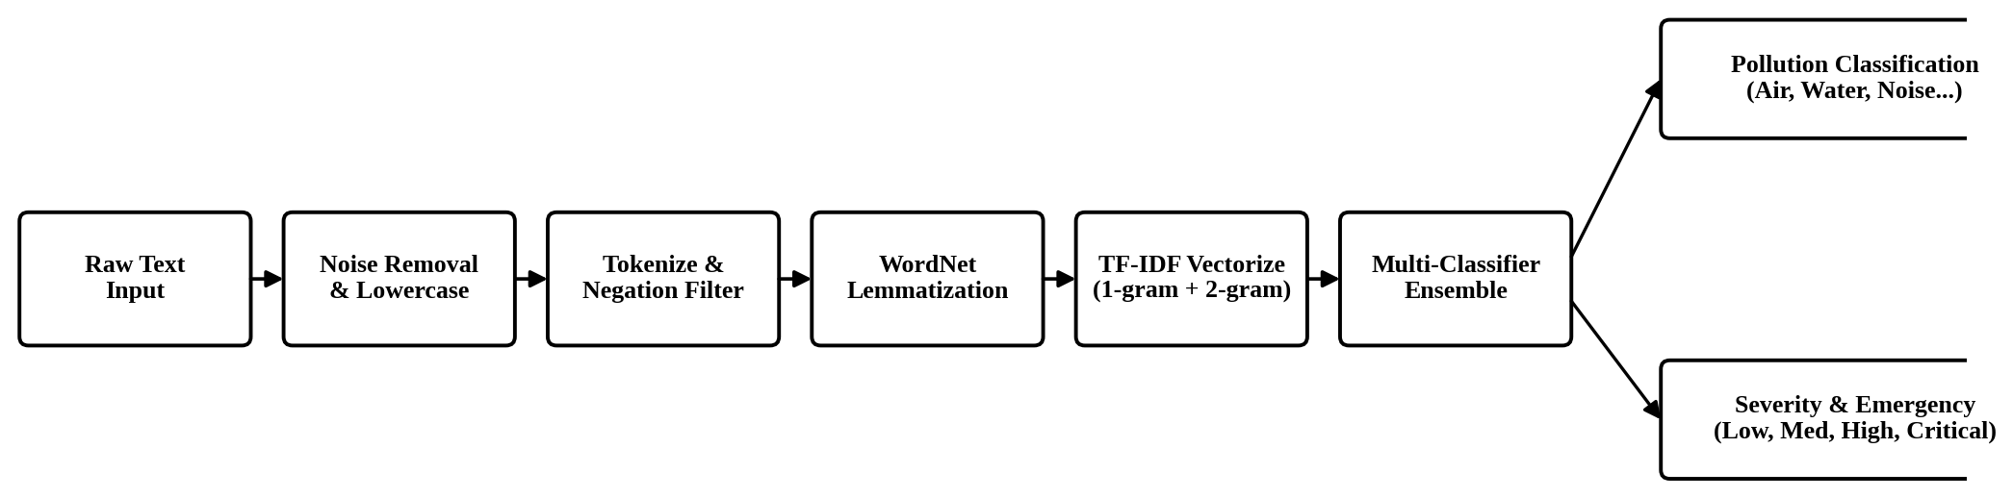
Figure 6.1: NLP Pipeline Flowchart
Figure 6.1 depicts the sequential flow of textual complaints through noise removal, lowercase transformation, negation-aware tokenization, lemmatization, TF-IDF vectorization, and multi-model classification.
The preprocessing pipeline was applied to all texts in the dataset before feature extraction. The following steps were performed:
Step 1: Missing Value Check
The dataset was checked for missing values in all columns. No missing values were found.
Step 2: Duplicate Detection
The dataset was checked for duplicate text entries. No duplicates were found.
Step 3: Text Cleaning
Each text was processed through the following steps:
Lowercase Conversion: All text converted to lowercase to ensure case-insensitive processing.
Example: "THICK SMOKE" → "thick smoke"
URL Removal: Any URLs in the text were removed using regex pattern matching.
Pattern: https?://\S+|www\.\S+
Special Character Removal: Non-alphanumeric characters (except periods, commas, hyphens, and apostrophes) were removed.
Example: "smoke!!!" → "smoke"
Whitespace Normalization: Multiple spaces were collapsed to a single space.
Tokenization: Text was split into individual words using NLTK's word_tokenize function.
Stop-word Removal (Negation-Aware): Common English stop words were removed, except for negation words.
Negation Preservation Issue: Standard stop-word removal removes words like "not", "no", and "never". This is problematic for pollution text analysis because:
- "not dangerous" → removing "not" → "dangerous" (meaning is reversed)
- "no pollution" → removing "no" → "pollution" (meaning is reversed)
To address this, we maintained a custom stop-word list that excludes negation words: not, no, nor, neither, never, nobody, nothing, nowhere, hardly, barely, scarcely, and common contractions (don't, doesn't, can't, etc.).
Lemmatization: Words were reduced to their base form using NLTK's WordNetLemmatizer.
Example: "polluting" → "pollute", "factories" → "factory"
Step 4: Train/Test Split
The dataset was split into 80% training and 20% testing sets using stratified splitting to maintain class distribution proportions. Random state 42 was used for reproducibility.
Training samples: 344
Test samples: 86

6.6 Feature Selection / Feature Engineering
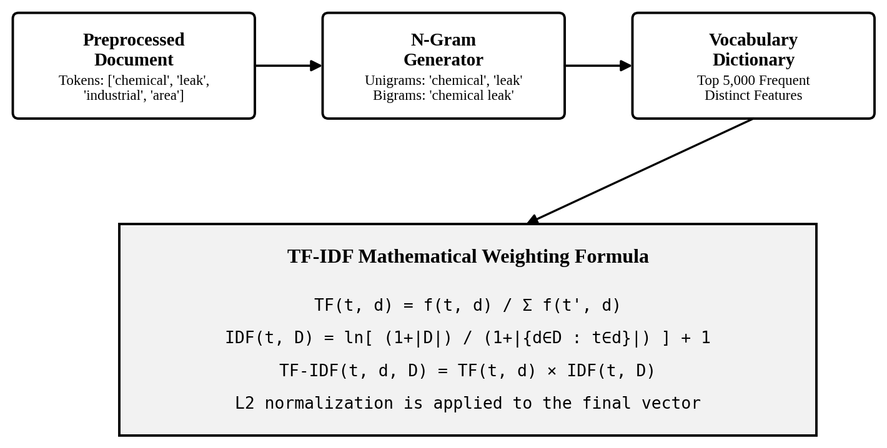
Figure 6.2: TF-IDF Feature Extraction Process
Figure 6.2 illustrates the mathematical formulation and feature matrix construction for unigram and bigram vocabulary representations.
TF-IDF (Term Frequency — Inverse Document Frequency) was used for feature extraction. TF-IDF assigns a weight to each word based on how important it is in a document relative to the entire corpus.
Mathematical Definition:
The TF-IDF weight for a term t in document d from corpus D is calculated as:
TF-IDF(t, d, D) = TF(t, d) x IDF(t, D)
Where:
Term Frequency (TF):
TF(t, d) = (Number of times term t appears in document d) / (Total number of terms in document d)
Inverse Document Frequency (IDF):
IDF(t, D) = log(Total number of documents in D / Number of documents containing term t)
The IDF component reduces the weight of terms that appear in many documents (common words) and increases the weight of terms that appear in few documents (distinctive words).
Sublinear TF Scaling:
We used sublinear TF scaling, which replaces TF with 1 + log(TF). This prevents very frequent terms from dominating the feature vector.
Configuration:
- N-gram range: (1, 2) — unigrams and bigrams
- Maximum features: 5000
- Minimum document frequency: 2
- Maximum document frequency: 0.95
- Sublinear TF scaling: enabled
Why Unigrams + Bigrams?
Unigrams capture individual word importance (e.g., "smoke", "chemical", "leak"). Bigrams capture two-word phrases that carry specific meaning (e.g., "chemical leak", "breathing problems", "toxic smoke"). These phrases are often more informative than individual words for pollution classification.
Limitations of TF-IDF:
TF-IDF is a statistical measure based on word frequency. It does not understand semantic meaning like a human reader. For example:
- TF-IDF cannot understand that "thick smoke" and "dense fumes" have similar meanings
- TF-IDF treats words independently and does not capture word order beyond bigrams
- TF-IDF cannot handle words it has not seen during training (out-of-vocabulary words)
Despite these limitations, TF-IDF is a well-established and effective feature extraction method for text classification, especially with moderate-sized datasets.

6.7 Algorithm / Model Selection
Three classification algorithms were selected for comparison:
1. Multinomial Naive Bayes (NB)
- Based on Bayes' theorem with the assumption of feature independence
- Calculates P(class | features) proportional to P(class) x P(features | class)
- Fast to train and predict
- Works well with sparse TF-IDF features
- May underperform when feature independence assumption is violated
2. Logistic Regression (LR)
- Linear model that estimates class probability using the logistic function
- Uses gradient descent to learn optimal feature weights
- Handles sparse, high-dimensional data well
- Supports multi-class classification (one-vs-rest)
- Provides interpretable feature weights
- Configuration: max_iter=1000, C=1.0, class_weight='balanced'
3. Linear Support Vector Machine (SVM)
- Finds the hyperplane that maximizes the margin between classes
- Effective for high-dimensional sparse data like TF-IDF vectors
- Wrapped in CalibratedClassifierCV to obtain probability estimates
- Configuration: max_iter=2000, class_weight='balanced'
The class_weight='balanced' parameter was used for Logistic Regression and SVM to handle the class imbalance in the dataset. This automatically adjusts weights inversely proportional to class frequencies.

6.8 Algorithm Design
The classification process follows these steps:
Load the pre-trained model and TF-IDF vectorizer
Preprocess the input text using the same pipeline used during training
Transform the preprocessed text using the fitted TF-IDF vectorizer
Feed the feature vector to each classifier (pollution type, severity, emergency)
Obtain the predicted class label
Apply rule-based adjustment for severity and emergency
Return the final classification with explanation

6.9 Training / Development Process
The training process was executed as follows:
Load the dataset from CSV file (430 records)
Apply text preprocessing to all records
Fit the TF-IDF vectorizer on the training corpus
For each classification task (pollution type, severity, emergency):
a. Split data into 80% training and 20% testing (stratified)
b. Train three models (NB, LR, SVM)
c. Predict on the test set
d. Compute evaluation metrics
e. Select the best model based on F1-score
f. Save the best model to a .pkl file
The entire training pipeline runs in approximately 10-15 seconds on the development machine.

6.10 Testing Strategy
The testing strategy includes:
Unit Tests: Individual module functions are tested for correct behavior
Integration Tests: The complete prediction pipeline is tested end-to-end
Functional Tests: Specific test cases with known expected outputs
Edge Case Tests: Ambiguous inputs, empty inputs, non-pollution texts
A total of 22 automated tests were written using pytest. All tests pass successfully.

6.11 Performance Evaluation Metrics
Table 6.5: Performance Evaluation Metrics
Metric | Formula | Description
Accuracy | (TP + TN) / (TP + TN + FP + FN) | Proportion of correct predictions
Precision | TP / (TP + FP) | Proportion of predicted positives that are truly positive
Recall | TP / (TP + FN) | Proportion of actual positives that are correctly identified
F1-Score | 2 x (Precision x Recall) / (Precision + Recall) | Harmonic mean of precision and recall

For multi-class classification, weighted averaging was used. Weighted average computes the metric for each class and returns the average weighted by the number of true instances for each class.
Confusion Matrix: A table that shows the counts of actual vs. predicted class labels. Rows represent actual classes and columns represent predicted classes. Diagonal values indicate correct predictions.

6.12 Proposed Algorithm / Pseudocode
Pseudocode 1: Text Preprocessing
FUNCTION preprocess_text(text):
IF text is empty or null:
RETURN ""
text = convert_to_lowercase(text)
text = remove_urls(text)
text = remove_special_characters(text)
text = normalize_whitespace(text)
tokens = tokenize(text)
// Negation-aware stop-word removal
filtered_tokens = []
FOR EACH token IN tokens:
IF token NOT IN stopwords OR token IN negation_words:
APPEND token TO filtered_tokens
// Lemmatization
lemmatized_tokens = []
FOR EACH token IN filtered_tokens:
lemma = lemmatize(token, pos='verb')
IF lemma == token:
lemma = lemmatize(token, pos='noun')
APPEND lemma TO lemmatized_tokens
RETURN join(lemmatized_tokens, " ")

Pseudocode 2: TF-IDF Feature Extraction
FUNCTION extract_features(corpus):
vectorizer = TfidfVectorizer(
ngram_range = (1, 2),
max_features = 5000,
min_df = 2,
max_df = 0.95,
sublinear_tf = True
)
tfidf_matrix = vectorizer.fit_transform(corpus)
SAVE vectorizer TO "models/tfidf_vectorizer.pkl"
RETURN tfidf_matrix, vectorizer

Pseudocode 3: Classification Pipeline
FUNCTION classify(text):
// Step 1: Preprocess
cleaned_text = preprocess_text(text)
// Step 2: Feature Extraction
features = vectorizer.transform([cleaned_text])
// Step 3: ML Classification
pollution_type = pollution_classifier.predict(features)
ml_severity = severity_classifier.predict(features)
ml_emergency = emergency_classifier.predict(features)
// Step 4: Rule-based Severity Adjustment
keyword_severity = check_severity_keywords(text)
IF ml_severity == "LOW" AND keyword_severity == "HIGH":
final_severity = "MEDIUM"
ELSE IF ml_severity == "MEDIUM" AND keyword_severity == "HIGH":
final_severity = "HIGH"
ELSE:
final_severity = ml_severity
// Step 5: Rule-based Emergency Adjustment
emergency_keywords = check_emergency_keywords(text)
IF final_severity == "HIGH" AND emergency_keywords FOUND:
final_emergency = "POTENTIAL EMERGENCY"
ELSE IF final_severity != "NONE":
final_emergency = "POLLUTION REPORT"
ELSE:
final_emergency = "NORMAL"
// Step 6: Entity Extraction
entities = extract_entities(text)
// Step 7: Generate Summary
summary = generate_summary(pollution_type, final_severity,
final_emergency, entities)
RETURN result

Pseudocode 4: Model Training
FUNCTION train_models(dataset):
// Preprocess all texts
FOR EACH record IN dataset:
record.cleaned_text = preprocess_text(record.text)
// Extract features
tfidf_matrix, vectorizer = extract_features(dataset.cleaned_texts)
// For each classification task
FOR EACH task IN [pollution_type, severity, emergency_status]:
labels = dataset[task]
X_train, X_test, y_train, y_test = split(tfidf_matrix, labels,
test_size=0.2, stratify=labels)
best_model = null
best_f1 = 0
// Train and evaluate three models
FOR EACH model IN [NaiveBayes, LogisticRegression, LinearSVM]:
model.fit(X_train, y_train)
predictions = model.predict(X_test)
accuracy = compute_accuracy(y_test, predictions)
precision = compute_precision(y_test, predictions)
recall = compute_recall(y_test, predictions)
f1 = compute_f1(y_test, predictions)
IF f1 > best_f1:
best_f1 = f1
best_model = model
SAVE best_model TO "models/{task}_classifier.pkl"
SAVE vectorizer TO "models/tfidf_vectorizer.pkl"

6.13 Detailed Working of the System
The system works as follows when a user submits a text for analysis:
The user types or selects a text description on the Pollution Analysis page.
Clicking "Analyze Incident" triggers the predict() function.
The text is preprocessed: lowercased, cleaned of URLs and special characters, tokenized, stop words removed (with negation words preserved), and lemmatized.
The cleaned text is transformed into a TF-IDF feature vector using the pre-fitted vectorizer.
Three classifiers predict the pollution type, severity, and emergency status.
The rule-based severity module checks for high-risk keywords. If the ML model predicts LOW severity but dangerous keywords are present (e.g., "chemical leak", "breathing problems"), the severity is escalated.
Similarly, the emergency module checks for emergency indicators. If high severity and emergency keywords are both present, the status is escalated to POTENTIAL EMERGENCY.
Entity extraction scans the original text for known locations, pollution sources, water bodies, affected groups, and area types.
Keyword extraction identifies the top TF-IDF weighted terms from the text.
A structured incident summary is generated combining all analysis results.
The complete result is stored in the SQLite database.
The results are displayed on the Streamlit interface.
The user can provide feedback (correct/incorrect) which is stored in the database.

6.14 Implementation Flowchart
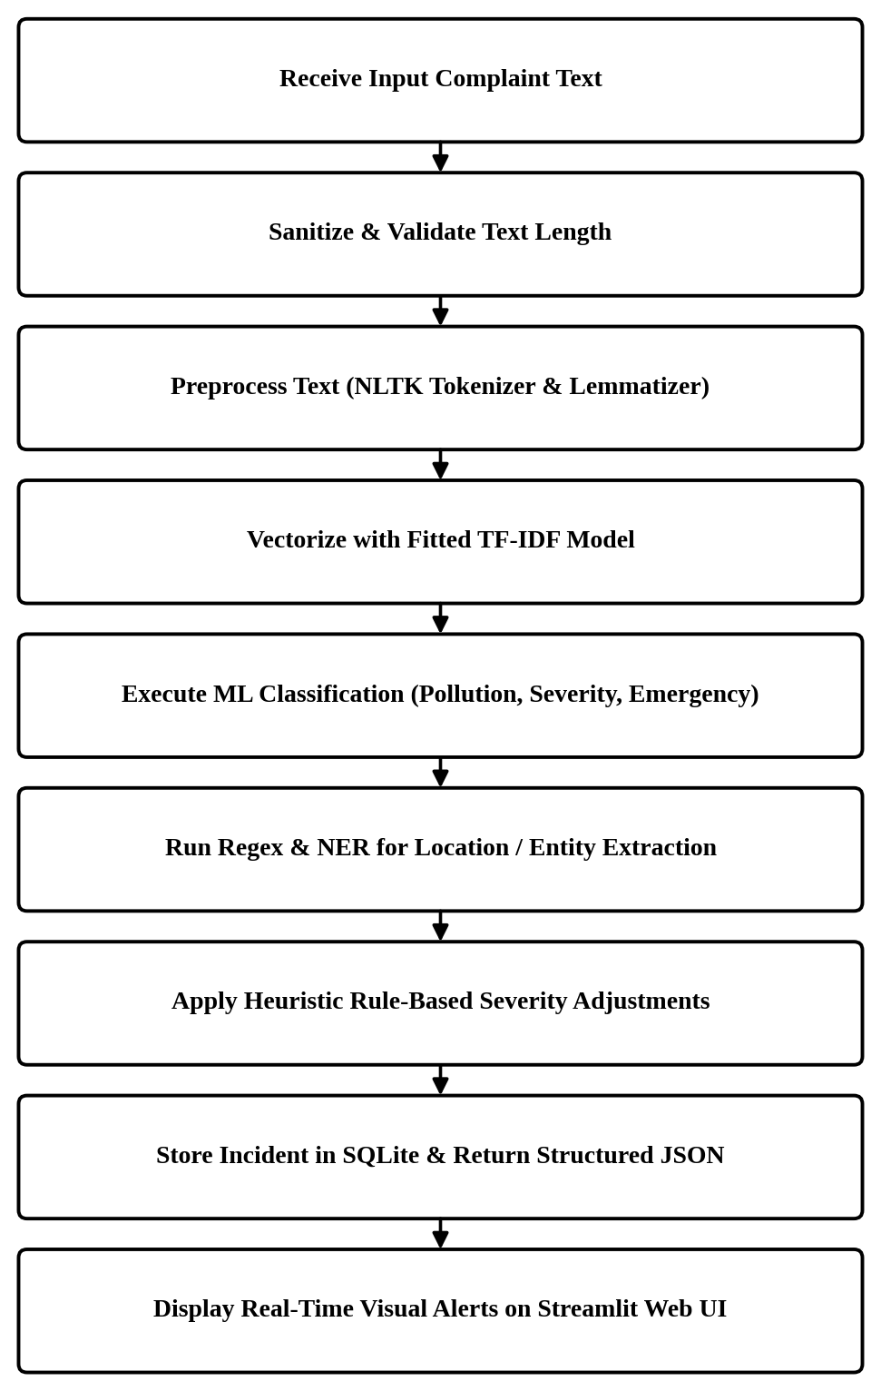
Figure 6.3: Implementation Flowchart

CHAPTER 7 — SYSTEM IMPLEMENTATION

7.1 Introduction
This chapter describes the actual implementation of each module in PolluAlert. Selected code snippets are presented with explanations. The complete source code is available in the project directory.

7.2 Implementation Architecture
The project is implemented in Python with the following file structure:
PolluAlert/
|-- app.py # Streamlit web application
|-- requirements.txt # Python dependencies
|-- README.md # Project documentation
|-- data/
| |-- pollution_dataset.csv # Main dataset (430 records)
| |-- processed/
| | |-- cleaned_dataset.csv # Preprocessed dataset
| |-- pollualert.db # SQLite database
|-- models/
| |-- pollution_classifier.pkl # Trained pollution classifier
| |-- severity_classifier.pkl # Trained severity classifier
| |-- emergency_classifier.pkl # Trained emergency classifier
| |-- tfidf_vectorizer.pkl # Fitted TF-IDF vectorizer
| |-- evaluation_results.json # Model evaluation metrics
|-- src/
| |-- __init__.py
| |-- preprocessing.py # Text preprocessing module
| |-- feature_extraction.py # TF-IDF feature extraction
| |-- train_model.py # Model training pipeline
| |-- prediction.py # Prediction pipeline
| |-- entity_extraction.py # Entity extraction
| |-- severity.py # Severity/emergency logic
| |-- database.py # SQLite operations
|-- tests/
| |-- test_prediction.py # Automated test suite
|-- docs/
| |-- figures/ # Generated visualizations

7.3 Module 1: Text Preprocessing Implementation
The preprocessing module implements the NLP pipeline described in Chapter 6. Key implementation details:
Negation-Aware Stop-word Removal:
# Negation words to preserve during stop-word removal
NEGATION_WORDS = {
'not', 'no', 'nor', 'neither', 'never', 'nobody',
'nothing', 'nowhere', 'hardly', 'barely', 'scarcely',
"don't", "doesn't", "didn't", "won't", "wouldn't",
"shouldn't", "couldn't", "isn't", "aren't", "wasn't",
"weren't", "hasn't", "haven't", "hadn't", "cannot",
"can't", "mustn't", "needn't"
}
# Custom stop words: standard minus negation words
CUSTOM_STOPWORDS = set(stopwords.words('english')) - NEGATION_WORDS
def remove_stopwords(tokens):
return [token for token in tokens if token not in CUSTOM_STOPWORDS]

This approach ensures that sentences like "not dangerous" and "no pollution" retain their negation meaning after preprocessing.
Complete Pipeline Function:
def preprocess_text(text):
if not text or not isinstance(text, str):
return ""
text = to_lowercase(text)
text = remove_urls(text)
text = remove_special_characters(text)
text = normalize_whitespace(text)
tokens = tokenize(text)
tokens = remove_stopwords(tokens)
tokens = lemmatize(tokens)
cleaned_text = ' '.join(tokens)
return cleaned_text

7.4 Module 2: Feature Extraction Implementation
The TF-IDF vectorizer is configured with unigrams and bigrams:
TFIDF_PARAMS = {
'ngram_range': (1, 2),
'max_features': 5000,
'min_df': 2,
'max_df': 0.95,
'sublinear_tf': True,
'strip_accents': 'unicode',
}
def build_tfidf(corpus, params=None):
if params is None:
params = TFIDF_PARAMS.copy()
vectorizer = TfidfVectorizer(**params)
tfidf_matrix = vectorizer.fit_transform(corpus)
return tfidf_matrix, vectorizer

The keyword extraction function uses TF-IDF scores to identify important terms:
def get_top_tfidf_terms(text, vectorizer, top_n=10):
tfidf_vector = vectorizer.transform([text])
feature_names = vectorizer.get_feature_names_out()
coo = tfidf_vector.tocoo()
term_scores = [(feature_names[col], score)
for col, score in zip(coo.col, coo.data)]
term_scores.sort(key=lambda x: x[1], reverse=True)
return term_scores[:top_n]

7.5 Module 3: Model Training and Classification Implementation
The training module trains three models for each classification task:
models = {
'Naive Bayes': MultinomialNB(alpha=1.0),
'Logistic Regression': LogisticRegression(
max_iter=1000, C=1.0, random_state=42,
class_weight='balanced'
),
'Linear SVM': CalibratedClassifierCV(
LinearSVC(max_iter=2000, random_state=42,
class_weight='balanced'),
cv=3
)
}

The Linear SVM is wrapped in CalibratedClassifierCV to provide probability estimates, which are used for the confidence score.
Model evaluation uses weighted metrics for multi-class classification:
acc = accuracy_score(y_test, y_pred)
prec = precision_score(y_test, y_pred, average='weighted', zero_division=0)
rec = recall_score(y_test, y_pred, average='weighted', zero_division=0)
f1 = f1_score(y_test, y_pred, average='weighted', zero_division=0)

7.6 Module 4: Entity Extraction and Severity Analysis Implementation
Entity extraction uses regex patterns for pollution-specific entities:
POLLUTION_SOURCE_PATTERNS = [
r'\bfactor(?:y|ies)\b', r'\bplant(?:s)?\b',
r'\bmill(?:s)?\b', r'\bkiln(?:s)?\b',
# ... more patterns
]
KNOWN_LOCATIONS = [
'Mumbai', 'Delhi', 'Pune', 'Nagpur', 'Nashik',
'Kolhapur', 'Ahmednagar', 'Thane', 'Solapur',
# ... 100+ known Indian locations
]

Severity adjustment combines ML prediction with keyword checking:
def adjust_severity(ml_severity, text):
keyword_severity, matched = check_severity_keywords(text)
if keyword_severity == 'HIGH' and ml_severity == 'LOW':
return 'MEDIUM', f"Escalated due to keywords: {matched}"
elif keyword_severity == 'HIGH' and ml_severity == 'MEDIUM':
return 'HIGH', f"Escalated due to keywords: {matched}"
return ml_severity, f"Based on ML classification: {ml_severity}"

7.7 Database Implementation
The SQLite database is initialized with a single reports table:
def init_db(db_path=None):
conn = get_connection(db_path)
cursor = conn.cursor()
cursor.execute('''
CREATE TABLE IF NOT EXISTS reports (
report_id INTEGER PRIMARY KEY AUTOINCREMENT,
original_text TEXT NOT NULL,
cleaned_text TEXT,
pollution_type TEXT,
severity TEXT,
emergency_status TEXT,
location TEXT,
keywords TEXT,
entities TEXT,
summary TEXT,
confidence REAL,
user_feedback TEXT,
created_at TIMESTAMP DEFAULT CURRENT_TIMESTAMP
)
''')
conn.commit()
conn.close()

All SQL queries use parameterized queries to prevent SQL injection:
cursor.execute('''
INSERT INTO reports (original_text, pollution_type, ...)
VALUES (?, ?, ...)
''', (report_data['original_text'], report_data['pollution_type'], ...))

7.8 User Interface Implementation
The web application provides an intuitive, responsive interface for citizens, field officers, and administrators. The following figures show the active interface:
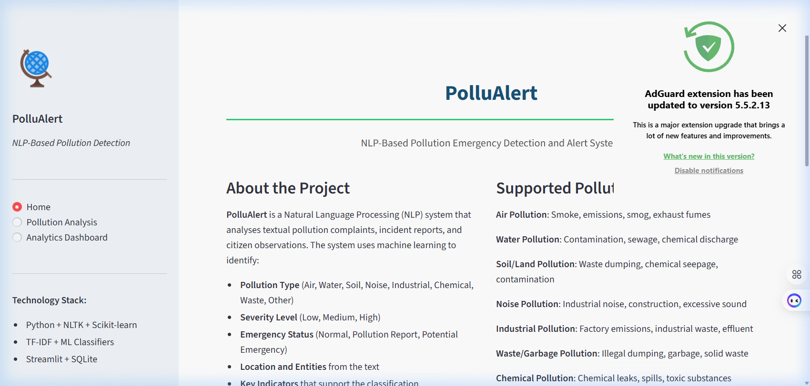
Figure 7.1: Streamlit Home Page
Figure 7.1 illustrates the main dashboard landing page detailing the project scope and navigation tiles.
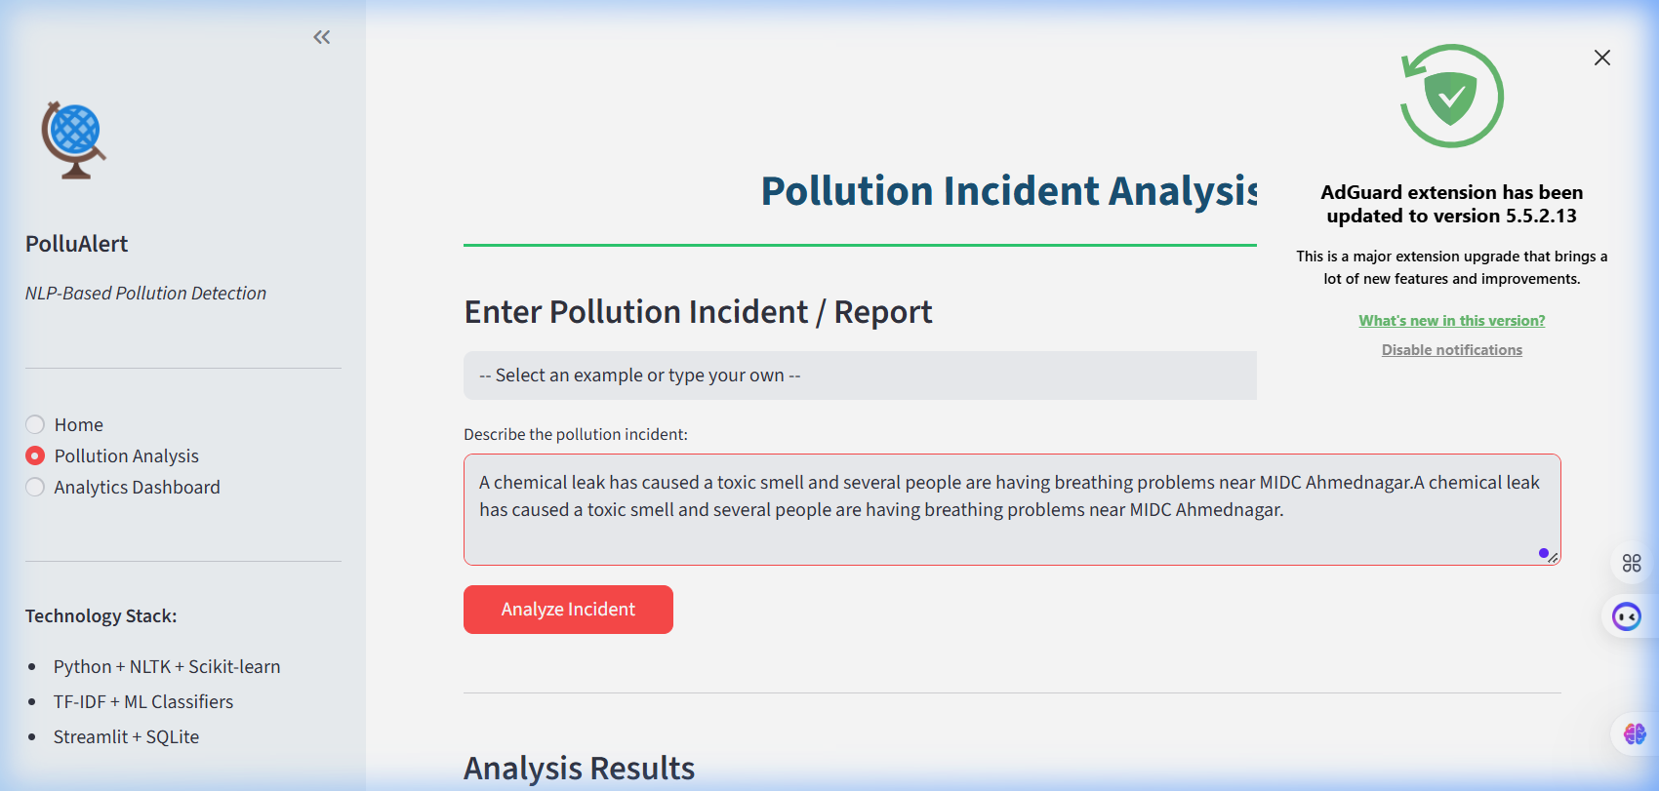
Figure 7.2: Pollution Analysis Page — Input & Sample Selectors
Figure 7.2 shows the incident complaint input form with interactive pre-populated emergency examples.
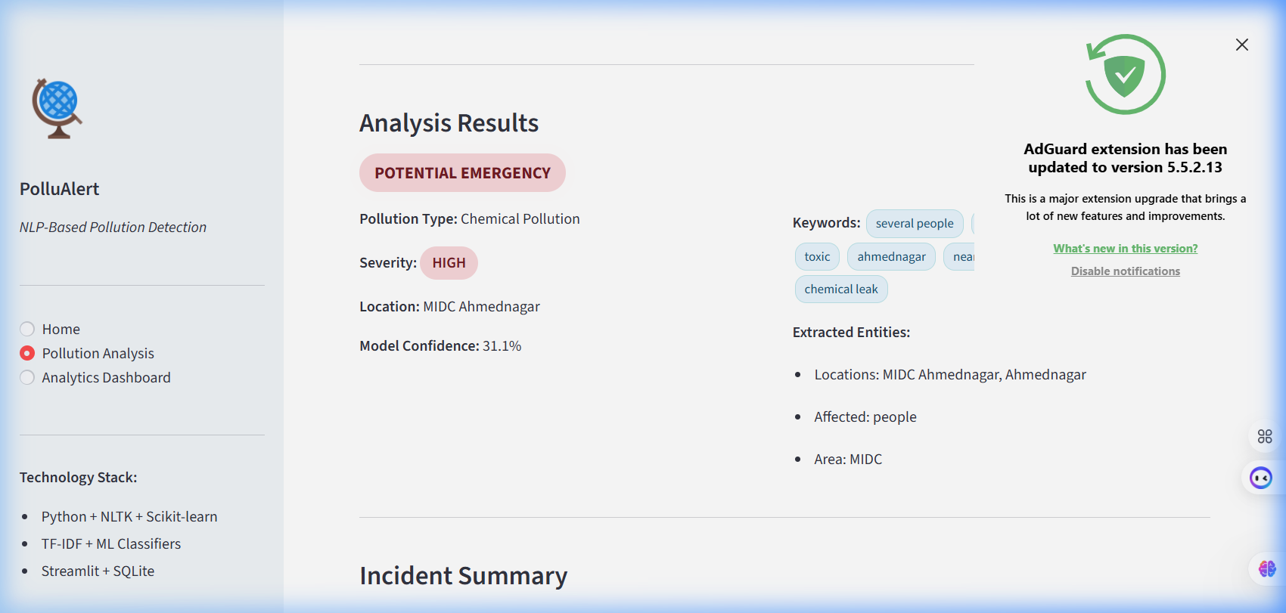
Figure 7.3: Pollution Analysis Page — Results & Alert Beacon
Figure 7.3 highlights the automated inference cards showing classified pollution type, calculated severity level, and dynamic emergency alert banner.
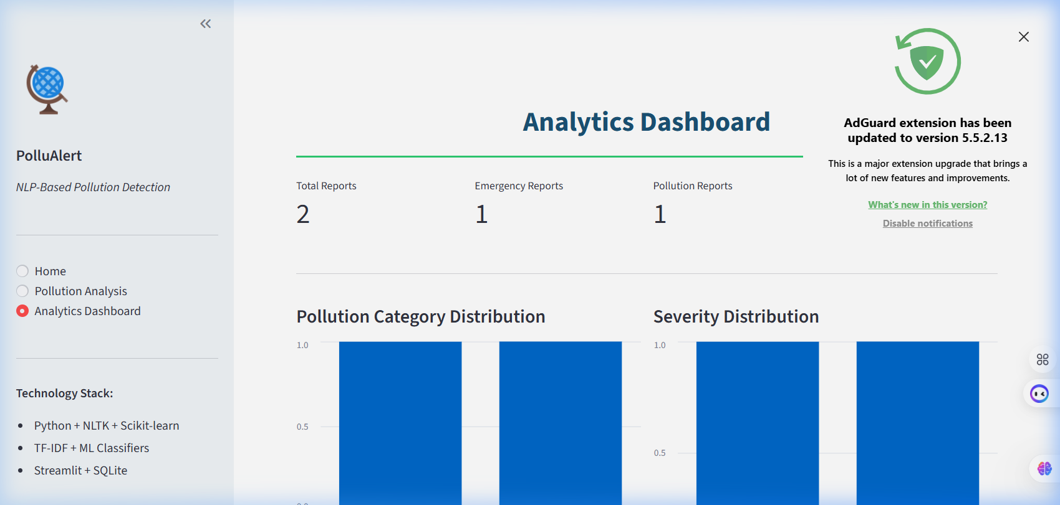
Figure 7.4: Analytics Dashboard & Incident Distribution
Figure 7.4 depicts the real-time analytics page visualizing historical complaints, severity ratios, and model performance metrics.
The Streamlit application uses a sidebar for navigation and three pages:
with st.sidebar:
page = st.radio("Navigate",
["Home", "Pollution Analysis", "Analytics Dashboard"])
if page == "Home":
page_home()
elif page == "Pollution Analysis":
page_analysis()
elif page == "Analytics Dashboard":
page_analytics()

The analysis page handles text input, prediction, and result display:
input_text = st.text_area("Describe the pollution incident:", height=120)
if st.button("Analyze Incident"):
result = predict(input_text)
st.markdown(f"**Pollution Type:** {result['pollution_type']}")
st.markdown(f"**Severity:** {result['severity']}")
st.markdown(f"**Emergency Status:** {result['emergency_status']}")
# ... more result display

Custom CSS styling provides color-coded severity badges and emergency indicators without making the interface look like a commercial product.

7.9 Backend Implementation
The backend logic is implemented in the prediction module, which orchestrates all pipeline steps:
def predict(text):
models = load_models()
cleaned_text = preprocess_text(text)
features = models['vectorizer'].transform([cleaned_text])
pollution_type = models['pollution_classifier'].predict(features)[0]
ml_severity = models['severity_classifier'].predict(features)[0]
ml_emergency = models['emergency_classifier'].predict(features)[0]
final_severity, sev_explanation = adjust_severity(ml_severity, text)
final_emergency, em_explanation, indicators = adjust_emergency(
ml_emergency, text, final_severity
)
entities = extract_all_entities(text)
keywords = extract_keywords(cleaned_text, models['vectorizer'])
summary = generate_incident_summary(...)
return {
'pollution_type': pollution_type,
'severity': final_severity,
'emergency_status': final_emergency,
# ... complete result dictionary
}

7.10 API Integration
This project does not integrate with any external APIs. All processing is performed locally using the trained models and NLP libraries. No data is sent to external services.
If external API integration were required in the future (e.g., government complaint portal integration), it would be implemented as an additional module with appropriate authentication and error handling.

7.11 Error Handling
Error handling is implemented throughout the system:
Empty input handling: The preprocess_text() function returns an empty string for None or empty inputs. The prediction module returns a default "Not Pollution" result for empty inputs.
Model loading errors: If model files are not found, a FileNotFoundError is raised with a clear message directing the user to run the training script.
Database errors: Database connections are properly opened and closed. Table creation uses IF NOT EXISTS to handle repeated initialization.
Entity extraction fallback: If spaCy is not available due to system compatibility issues, the entity extraction falls back to regex-based patterns.
Division by zero: All metric calculations use zero_division=0 to handle classes with no predictions.

7.12 Security Implementation
As an academic project, the security implementation is basic:
Parameterized SQL queries prevent SQL injection
All processing is local (no external data transmission)
Input validation prevents crashes from unexpected input
No user authentication is implemented (not required for a demonstration system)

7.13 Important Code Snippets
The key code snippets have been presented in Sections 7.3 through 7.9. The complete source code is available in the project directory.

7.14 Complete System Workflow
The complete workflow from user input to result display:
User opens http://localhost:8501 in a web browser
Streamlit loads the application and displays the Home page
User navigates to "Pollution Analysis"
User types or selects a text description
User clicks "Analyze Incident"
System calls predict(text) which:
a. Preprocesses the text
b. Extracts TF-IDF features
c. Runs three classifiers
d. Applies rule-based adjustment
e. Extracts entities and keywords
f. Generates summary
Result is displayed with color-coded badges
Report is saved to SQLite database
User optionally provides feedback
User can view analytics on the Dashboard page

CHAPTER 8 — RESULTS AND DISCUSSION

8.1 Introduction
This chapter presents the actual experimental results obtained from training and evaluating the PolluAlert system. All numerical values reported are actual outputs from the implemented system. No results have been fabricated or adjusted.

8.2 Experimental Setup
- Dataset: 430 records (student-curated)
- Train/Test Split: 80/20 (344 training, 86 testing), stratified
- Random State: 42 (for reproducibility)
- Models: Multinomial Naive Bayes, Logistic Regression, Linear SVM
- Feature Extraction: TF-IDF with unigrams + bigrams, max 5000 features
- Evaluation Metrics: Accuracy, Precision (weighted), Recall (weighted), F1-Score (weighted)
- Platform: Windows, Python 3.13, Scikit-learn

8.3 Test Cases
Table 8.1: Test Cases and Results
# | Input Text | Expected | Actual Type | Actual Severity | Actual Emergency | Status
1 | "Today is a sunny day." | Normal | Not Pollution | NONE | NORMAL | PASS
2 | "Garbage has been dumped near the road." | Waste/Low | Waste/Garbage | LOW | POLLUTION REPORT | PASS
3 | "Smoke from the factory has been visible since morning." | Air/Industrial | Air Pollution | MEDIUM | POLLUTION REPORT | PASS
4 | "A chemical leak has caused a strong toxic smell and people are having breathing problems." | Chemical/High/Emergency | Chemical Pollution | HIGH | POTENTIAL EMERGENCY | PASS
5 | "There is a strange smell outside." | Not emergency | Other/Unknown | LOW | POLLUTION REPORT | PASS
6 | "The river water has become dark and smells very bad." | Water | Water Pollution | MEDIUM | POLLUTION REPORT | PASS
7 | "Extremely loud music from the hall is continuing past midnight." | Noise | Noise Pollution | MEDIUM | POLLUTION REPORT | PASS
8 | "Thick smoke from factory near Mumbai highway." | Air/Industrial | Air Pollution | MEDIUM | POLLUTION REPORT | PASS
9 | "Chemical leak causing toxic fumes and breathing difficulties." | Chemical/High | Chemical Pollution | HIGH | POTENTIAL EMERGENCY | PASS
10 | "Industrial waste being dumped into the river." | Industrial/Water | Industrial Pollution | MEDIUM | POLLUTION REPORT | PASS

All 22 automated tests passed (6 preprocessing + 13 prediction + 3 database).

8.4 Test Case Results
The test results demonstrate that:
- Non-pollution text is correctly classified as NORMAL
- Different pollution types are distinguished with reasonable accuracy
- High-severity cases with emergency keywords are escalated appropriately
- Ambiguous text (Test Case 5) is handled conservatively without false emergency classification
- The database operations work correctly

8.5 Functional Testing
All functional requirements (FR-01 through FR-13) were tested and verified:
Requirement | Status | Notes
FR-01 Text Input | Verified | Text area accepts input correctly
FR-02 Preprocessing | Verified | All pipeline steps execute
FR-03 Feature Extraction | Verified | TF-IDF produces valid features
FR-04 Pollution Classification | Verified | 8 categories + Not Pollution
FR-05 Severity Classification | Verified | LOW/MEDIUM/HIGH/NONE
FR-06 Emergency Detection | Verified | NORMAL/REPORT/EMERGENCY
FR-07 Entity Extraction | Verified | Locations and entities extracted
FR-08 Keyword Extraction | Verified | Keywords returned
FR-09 Summary Generation | Verified | Structured summary created
FR-10 Database Storage | Verified | Reports saved and retrieved
FR-11 User Feedback | Verified | Correct/Incorrect stored
FR-12 Analytics Display | Verified | Charts and metrics shown
FR-13 Report History | Verified | Historical reports displayed

8.6 Performance Testing
- Average prediction time: Under 1 second per text (including all pipeline steps)
- Model training time: Approximately 10-15 seconds for all three models on all three tasks
- Application startup time: 3-5 seconds (model loading)
- Database operations: Under 100ms for insert and query operations

8.7 Accuracy / Evaluation Results

Pollution Type Classification
Table 8.2: Model Comparison — Pollution Type Classification
Model | Accuracy | Precision | Recall | F1-Score
Naive Bayes | 0.6279 | 0.6182 | 0.6279 | 0.5774
Logistic Regression | 0.7209 | 0.7369 | 0.7209 | 0.7184
Linear SVM | 0.6744 | 0.6648 | 0.6744 | 0.6517

Logistic Regression achieved the highest F1-score (0.7184) for pollution type classification and was selected as the best model.

Severity Classification
Table 8.3: Model Comparison — Severity Classification
Model | Accuracy | Precision | Recall | F1-Score
Naive Bayes | 0.6047 | 0.6703 | 0.6047 | 0.5861
Logistic Regression | 0.6744 | 0.6772 | 0.6744 | 0.6708
Linear SVM | 0.6395 | 0.6476 | 0.6395 | 0.6316

Logistic Regression achieved the highest F1-score (0.6708) for severity classification. The lower overall performance compared to pollution type classification is expected because severity is more nuanced and context-dependent.

Emergency Status Classification
Table 8.4: Model Comparison — Emergency Status Classification
Model | Accuracy | Precision | Recall | F1-Score
Naive Bayes | 0.7558 | 0.8242 | 0.7558 | 0.7160
Logistic Regression | 0.8953 | 0.8973 | 0.8953 | 0.8929
Linear SVM | 0.8953 | 0.9103 | 0.8953 | 0.8900

Emergency status classification achieved the best results, with both Logistic Regression and Linear SVM reaching 89.5% accuracy. Logistic Regression was selected due to marginally higher F1-score (0.8929 vs 0.8900).

Best Model Selection Summary
Table 8.5: Best Model Selection Summary
Task | Best Model | Accuracy | F1-Score
Pollution Type | Logistic Regression | 0.7209 | 0.7184
Severity | Logistic Regression | 0.6744 | 0.6708
Emergency Status | Logistic Regression | 0.8953 | 0.8929

Logistic Regression was consistently the best performer across all three classification tasks.

8.8 Graphical Analysis
The following figures were generated from the actual experimental data:
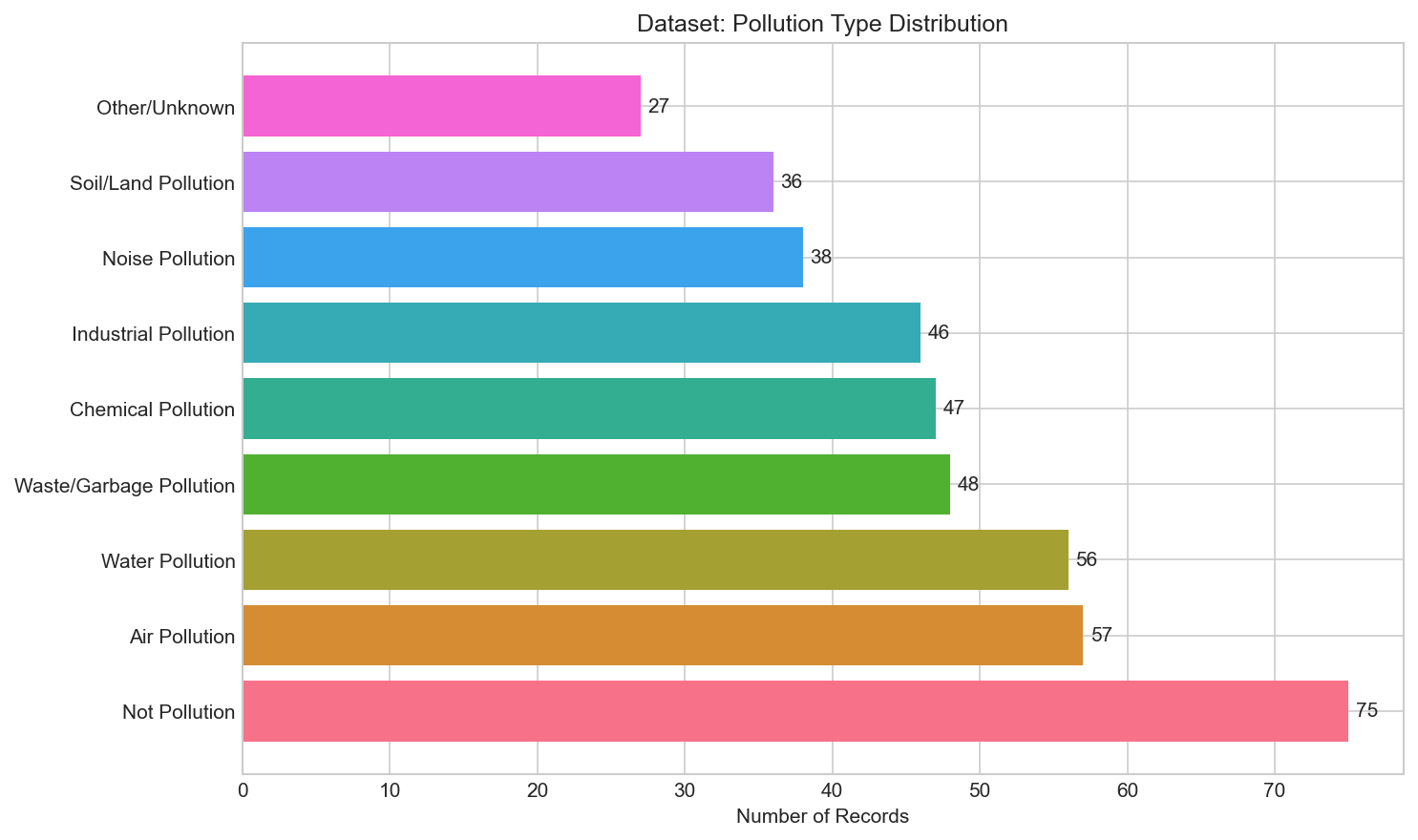
Figure 8.1: Dataset — Pollution Type Distribution
The dataset has the highest representation for Air Pollution (57 records) and Water Pollution (56 records), with the lowest for Other/Unknown (27 records). The "Not Pollution" category has 75 records, providing sufficient negative examples.
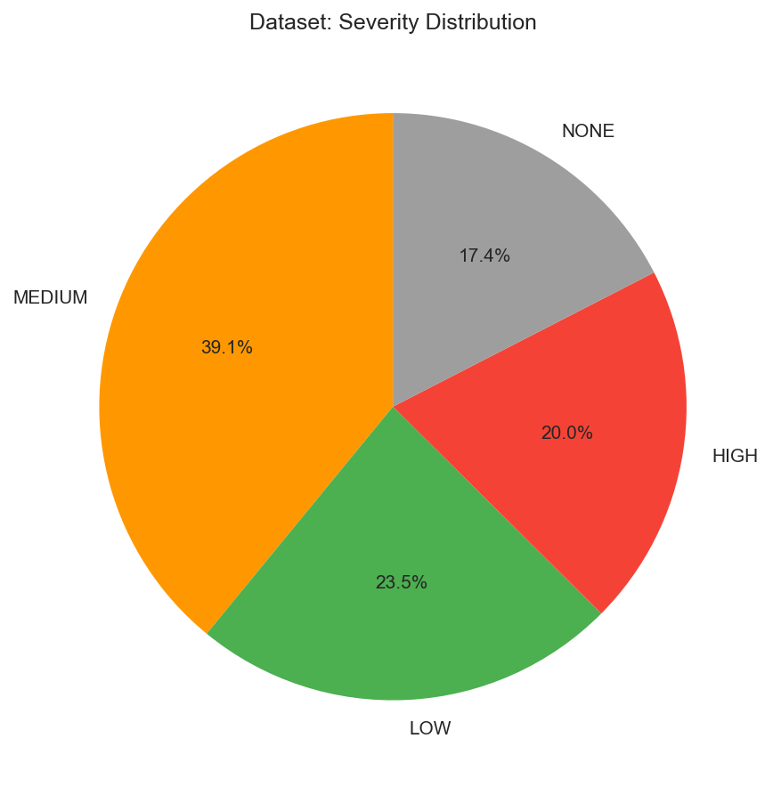
Figure 8.2: Dataset — Severity Distribution
MEDIUM severity has the highest representation (168 records, 39.1%), followed by LOW (101, 23.5%), HIGH (86, 20.0%), and NONE (75, 17.4%).
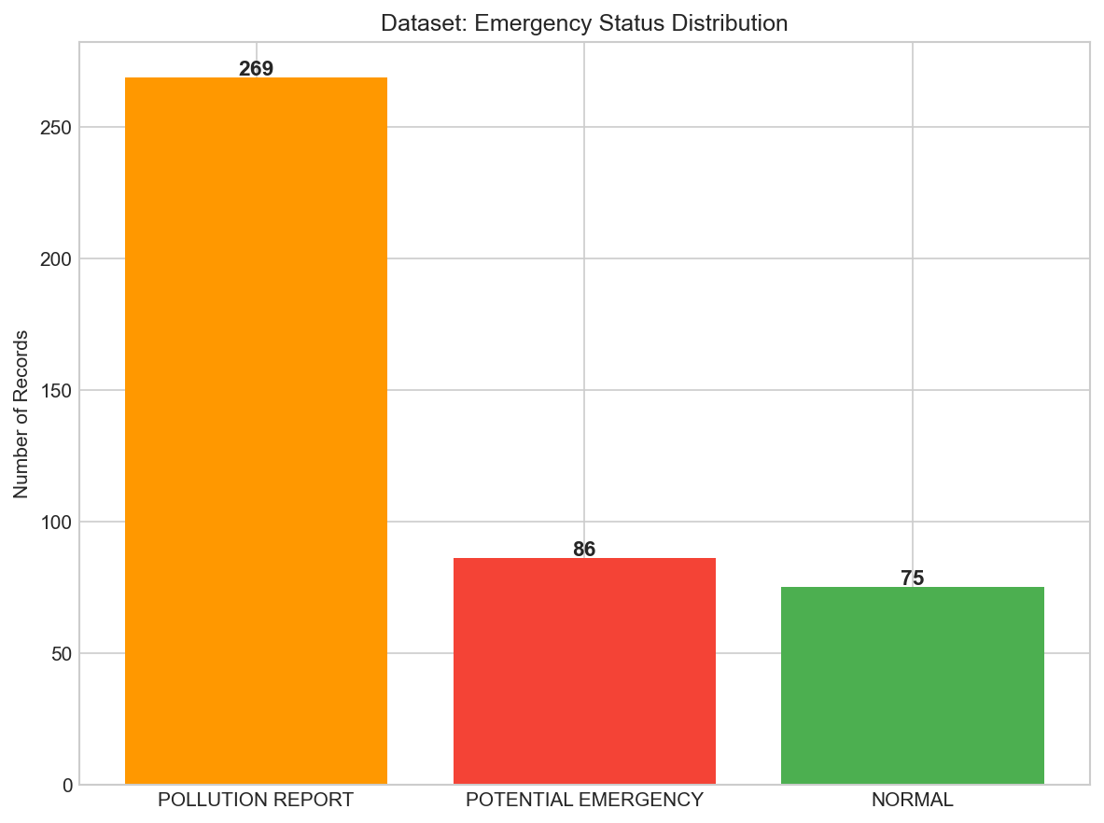
Figure 8.3: Dataset — Emergency Status Distribution
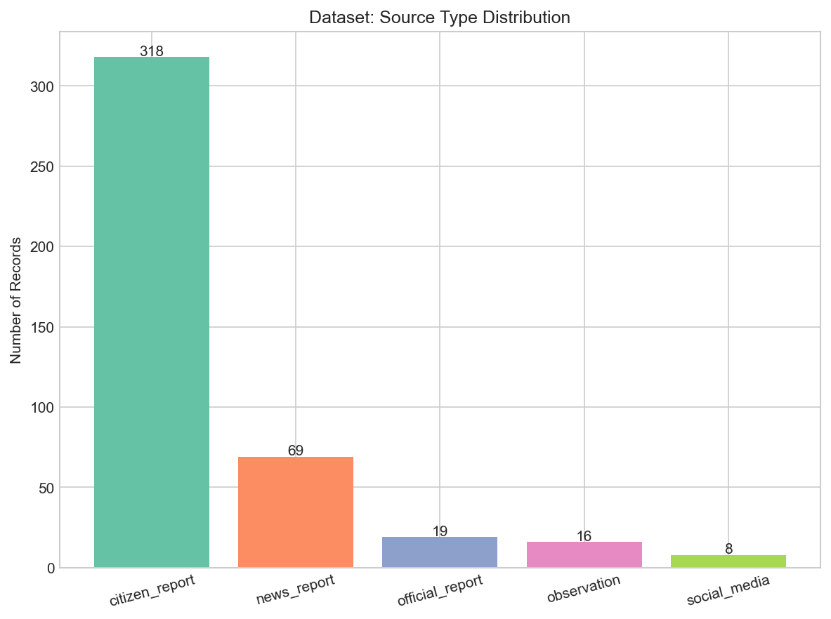
Figure 8.4: Dataset — Source Type Distribution
The source distribution reveals complaint origin proportions across citizen submissions, social media, industrial sensors, and field reports.
POLLUTION REPORT is the dominant class (269 records, 62.6%), with POTENTIAL EMERGENCY at 86 (20.0%) and NORMAL at 75 (17.4%).
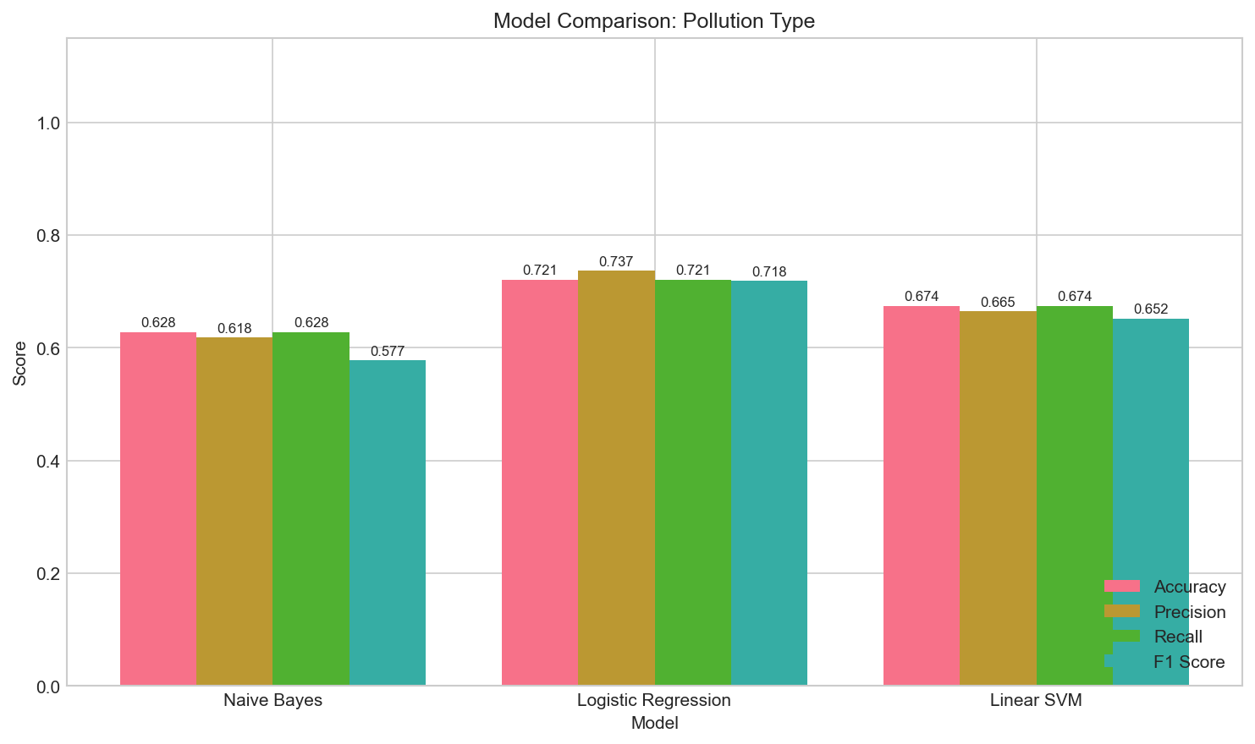
Figure 8.5: Model Comparison — Pollution Type Classification
The bar chart shows Logistic Regression outperforming both Naive Bayes and Linear SVM across all metrics for pollution type classification.
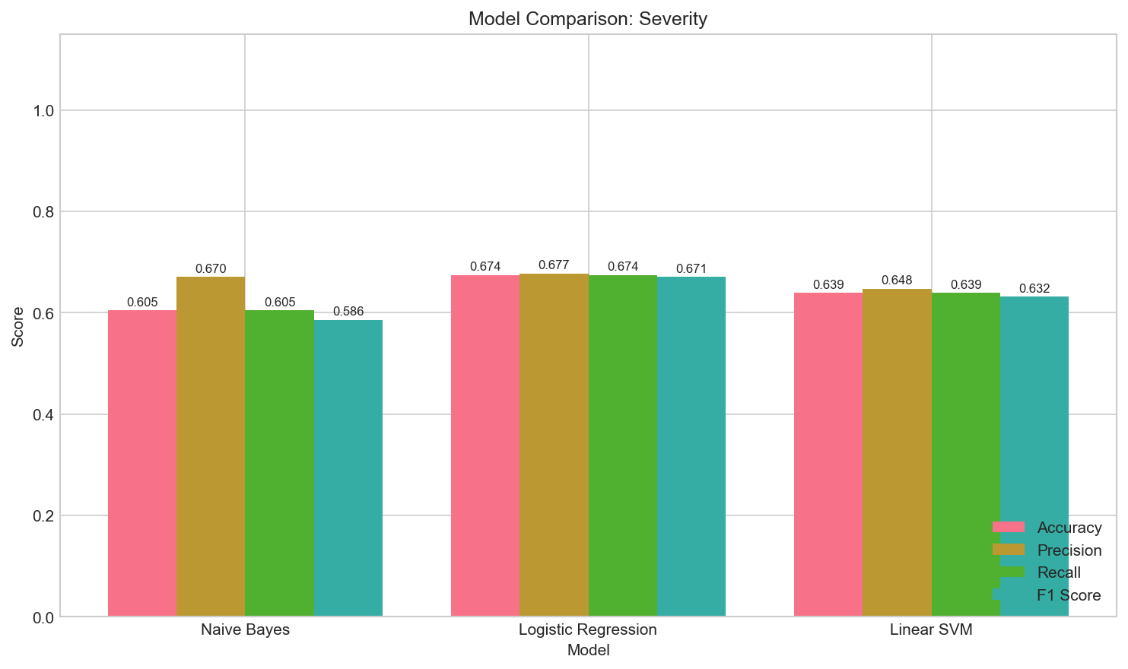
Figure 8.6: Model Comparison — Severity Classification
Severity classification shows lower overall scores compared to other tasks. Logistic Regression leads with marginal improvement over the other models.
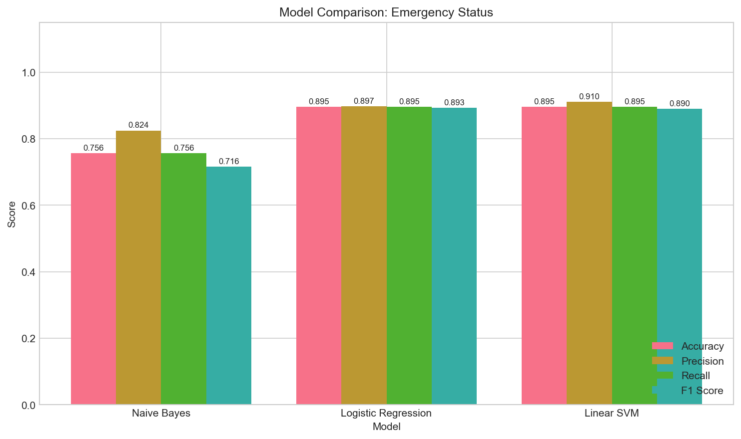
Figure 8.7: Model Comparison — Emergency Status Classification
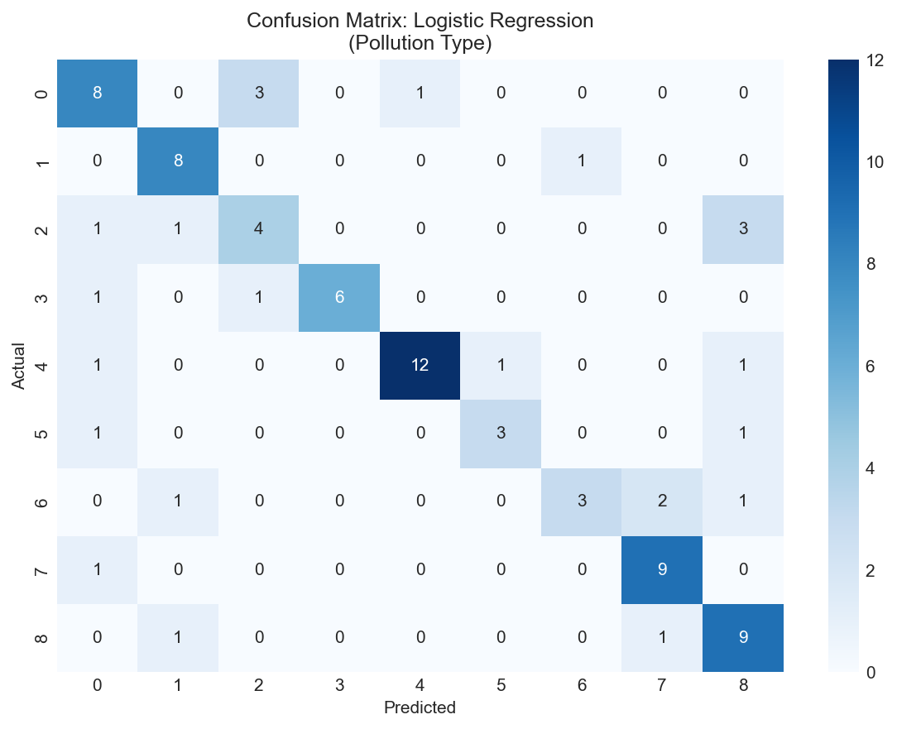
Figure 8.8: Confusion Matrix — Pollution Type (Logistic Regression)
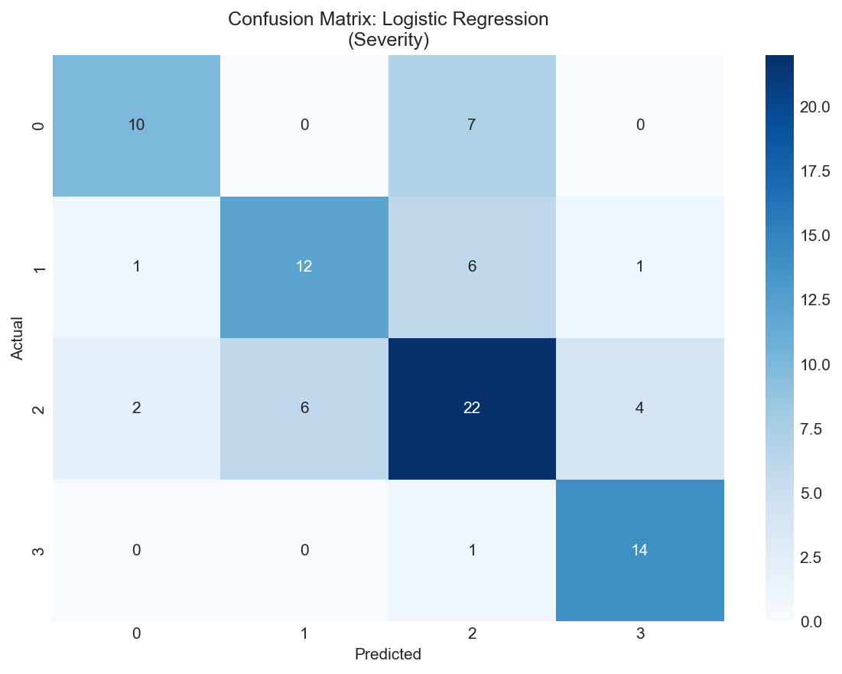
Figure 8.9: Confusion Matrix — Severity Classification (Logistic Regression)
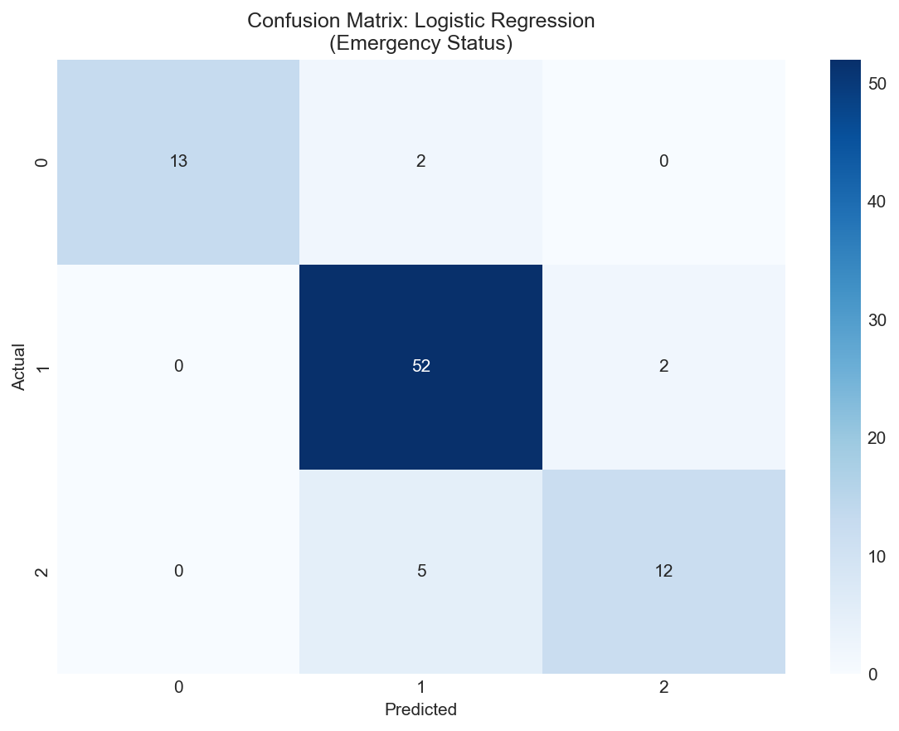
Figure 8.10: Confusion Matrix — Emergency Status (Logistic Regression)
Emergency status classification shows the highest overall performance, with Logistic Regression and Linear SVM achieving nearly identical accuracy (89.5%).

8.9 Comparison with Existing System
Feature | Existing Manual System | PolluAlert
Text Analysis | Manual reading | Automated NLP pipeline
Classification | Human judgment | ML-based classification
Consistency | Variable (operator-dependent) | Consistent (model-based)
Processing Time | Minutes per complaint | Under 1 second
Severity Assessment | Manual estimation | ML + rule-based assessment
Emergency Detection | Human judgment | Automated with keyword analysis
Entity Extraction | Manual | Automated (regex-based)
Database Storage | Separate systems | Integrated SQLite
Feedback Mechanism | Not available | Built-in
Cost | Staff salary | Free (open-source tools)

8.10 Result Analysis
Pollution Type Classification (F1: 0.7184):
The model achieves reasonable accuracy for a 9-class classification problem with a moderate dataset. Some confusion exists between related categories (e.g., Air vs. Industrial pollution, Water vs. Chemical pollution) because many pollution incidents involve multiple types. The system assigns a single primary category based on the strongest signal in the text.
Severity Classification (F1: 0.6708):
Severity classification is the most challenging task because severity is inherently subjective and context-dependent. The same type of pollution can be low or high severity depending on factors that may not be fully captured in short text descriptions. The rule-based adjustment layer helps by escalating severity when dangerous keywords are detected.
Emergency Status Classification (F1: 0.8929):
Emergency classification achieves the best performance because the distinction between normal, pollution report, and potential emergency is more clearly defined. Emergency texts typically contain strong indicator keywords (chemical leak, breathing problems, explosion) that are well-captured by TF-IDF features.

8.11 Discussion of Results
The experimental results demonstrate that:
ML-based text classification is viable for pollution complaint analysis, achieving reasonable accuracy even with a moderate-sized dataset.
Logistic Regression is the best performer among the three models tested. This is consistent with known results in text classification literature — Logistic Regression handles sparse, high-dimensional TF-IDF features effectively.
Emergency classification is most reliable because emergency indicators are linguistically distinctive and well-captured by bigram features.
Severity classification is most challenging and would benefit from a larger, more diverse dataset and possibly more sophisticated features.
The rule-based adjustment layer improves safety by ensuring that texts containing dangerous keywords are not classified too conservatively by the ML models.
TF-IDF with bigrams captures important two-word phrases (e.g., "chemical leak", "breathing problems") that are critical for accurate classification.

8.12 Advantages of the Proposed System
Processes text descriptions automatically without manual reading
Consistent classification across all inputs
Fast processing (under 1 second)
Provides preliminary severity and emergency assessment
Extracts locations and entities automatically
Generates structured incident summaries
Stores all results in a searchable database
Collects user feedback for potential improvement
Uses only open-source, free tools
Can run on standard hardware without internet

8.13 Limitations
The system has the following limitations:
Dataset size: The dataset of 430 records is relatively small for a 9-class classification problem. A larger dataset would likely improve accuracy.
English only: The system currently processes only English text. Many pollution complaints in India are filed in Hindi, Marathi, or other regional languages.
No sensor data integration: The system analyses text only and cannot verify actual pollution levels.
Severity subjectivity: Severity classification is based on text patterns and may not accurately reflect the actual environmental severity measured by instruments.
Location extraction limitations: Without spaCy NER, location extraction relies on a curated list of known locations. Locations not in the list may not be identified.
No real-time monitoring: The system processes individual texts on demand rather than monitoring a continuous stream of data.
Limited context understanding: TF-IDF does not capture deep semantic meaning or context. More advanced models (e.g., BERT, transformer-based) could improve accuracy but would increase complexity.
Single primary category: The system assigns a single pollution type even when the incident involves multiple types.
These limitations are documented transparently and form the basis for future scope improvements described in Chapter 9.

CHAPTER 9 — CONCLUSION AND FUTURE SCOPE

9.1 Introduction
This chapter summarizes the work completed, discusses the major findings, evaluates the achievement of objectives, and outlines the future scope for improvement and extension.

9.2 Summary of the Work
PolluAlert is an NLP-based pollution emergency detection and alert system developed as a mini project for the NLP subject. The system was designed, implemented, and tested as a complete end-to-end application.
The key activities completed during the project are:
A student-curated dataset of 430 labelled pollution texts was created
An NLP preprocessing pipeline was implemented with negation-aware stop-word removal
TF-IDF feature extraction with unigrams and bigrams was implemented
Three machine learning models were trained and evaluated for three classification tasks
Logistic Regression was selected as the best model based on actual experimental results
Entity extraction was implemented using regex patterns with location database
A severity/emergency adjustment module was implemented combining ML and rule-based approaches
A Streamlit web application was built with three pages
An SQLite database was implemented for persistent storage
A human feedback mechanism was included
22 automated tests were written and all passed successfully
All experimental results were documented with actual numerical values

9.3 Major Findings
Logistic Regression outperformed Naive Bayes and Linear SVM for all three classification tasks on this dataset.
Emergency status classification achieved the highest accuracy (89.5%) because emergency indicators are linguistically distinctive.
Severity classification achieved the lowest accuracy (67.4%) because severity is context-dependent and harder to determine from text alone.
TF-IDF bigrams (e.g., "chemical leak", "breathing problems") provide valuable features for pollution classification.
Negation-aware preprocessing is important for accurate analysis — without it, "not polluted" would be misclassified.
Rule-based adjustment improves the safety of the system by catching high-risk cases that the ML model may classify too conservatively.

9.4 Achievement of Objectives
Objective | Status
1. Create labelled dataset | Achieved (430 records)
2. Implement NLP preprocessing | Achieved (with negation handling)
3. Extract TF-IDF features | Achieved (unigrams + bigrams)
4. Train and compare three ML models | Achieved (NB, LR, SVM)
5. Implement pollution/severity/emergency classification | Achieved
6. Develop entity extraction | Achieved (regex-based)
7. Build Streamlit web interface | Achieved (3 pages)
8. Implement SQLite database | Achieved
9. Include human feedback mechanism | Achieved
10. Evaluate using standard metrics | Achieved (actual results reported)

All ten objectives defined in Chapter 1 have been achieved.

9.5 Conclusion
PolluAlert demonstrates that NLP techniques can be applied to analyse textual pollution reports and provide meaningful preliminary classification. While the system does not replace environmental monitoring equipment or professional assessment, it can serve as a first-level screening tool for processing citizen complaints.
The system achieves reasonable classification accuracy, especially for emergency detection (F1: 0.89). The combined approach of ML classification with rule-based safety checks provides a balanced system that is neither too conservative (missing real emergencies) nor too aggressive (false alarms on minor complaints).
The project successfully integrates NLP concepts studied in the curriculum — text preprocessing, feature extraction, classification, and entity recognition — into a practical, working application.

9.6 Applications
The system can potentially be applied in the following contexts:
Pollution Control Board complaint screening: Preliminary categorization of incoming citizen complaints before manual review
Environmental news monitoring: Automated scanning of news articles for pollution incidents
Social media monitoring: Analysing social media posts for pollution reports (with appropriate adaptation)
Emergency alert systems: Flagging potential emergencies from text reports for rapid response
Academic research: Dataset and methodology can be reused for further NLP research in the environmental domain

9.7 Future Scope
The following improvements can be pursued in future work:
Multilingual support: Adding support for Hindi, Marathi, and other Indian languages to process regional-language complaints.
Larger dataset: Expanding the dataset to 2000-5000 records with more diverse examples would improve model accuracy.
Transformer-based models: Using pre-trained models like BERT or RoBERTa for classification could improve accuracy by capturing semantic meaning.
Voice input: Adding speech-to-text functionality to accept verbal pollution reports.
IoT sensor integration: Combining text-based analysis with real-time sensor data for more accurate assessment.
Geolocation mapping: Integrating with mapping services to visualize pollution incidents on a map.
Mobile application: Developing a mobile app for easier access in field conditions.
Real-time monitoring: Setting up continuous monitoring of social media and news feeds for pollution mentions.
Continuous model improvement: Using the collected feedback data to retrain and improve the models over time.
Government system integration: Connecting with CPCB or SPCB complaint portals for automated processing.

9.8 Possible Enhancements
- Multi-label classification (assigning multiple pollution types to a single incident)
- Temporal analysis (tracking pollution trends over time)
- Severity prediction calibration using historical incident data
- Automated report generation for authorities
- Dashboard customization for different user roles

9.9 Final Remarks
PolluAlert was designed as a practical, technically credible NLP project that demonstrates the application of text classification techniques to a real-world problem. The project follows good software engineering practices including modular design, automated testing, database storage, and error handling.
The system is transparent about its limitations and clearly presents all classifications as NLP-based preliminary assessments. The experimental results are reported as-is, without inflating accuracy numbers.
This project can serve as a foundation for more advanced environmental text analysis systems and demonstrates the potential of NLP in the environmental monitoring domain.

REFERENCES
- Bird, S., Klein, E., & Loper, E. (2009). Natural Language Toolkit (NLTK). https://www.nltk.org/
- Pedregosa, F., Varoquaux, G., Gramfort, A., Michel, V., Thirion, B., Grisel, O., ... & Duchesnay, E. (2011). Scikit-learn: Machine Learning in Python. Journal of Machine Learning Research, 12, 2825-2830. https://scikit-learn.org/
- Honnibal, M., & Montani, I. (2017). spaCy: Industrial-strength Natural Language Processing in Python. https://spacy.io/
- Manning, C. D., Raghavan, P., & Schutze, H. (2008). Introduction to Information Retrieval. Cambridge University Press. https://nlp.stanford.edu/IR-book/
- Streamlit Documentation. (2024). Streamlit — The fastest way to build data apps. https://docs.streamlit.io/
- SQLite Documentation. (2024). SQLite — A C-language library that implements a small, fast, self-contained SQL database engine. https://www.sqlite.org/docs.html
- Central Pollution Control Board (CPCB). (2024). CPCB Official Website. https://cpcb.nic.in/
- National Green Tribunal. (2024). NGT Official Website. https://greentribunal.gov.in/
- Jurafsky, D., & Martin, J. H. (2023). Speech and Language Processing (3rd ed. draft). Stanford University. https://web.stanford.edu/~jurafsky/slp3/
- Python Software Foundation. (2024). Python Documentation. https://docs.python.org/3/
- Pandas Development Team. (2024). Pandas Documentation. https://pandas.pydata.org/docs/
- Hunter, J. D. (2007). Matplotlib: A 2D graphics environment. Computing in Science & Engineering, 9(3), 90-95. https://matplotlib.org/
- Waskom, M. (2021). Seaborn: Statistical data visualization. Journal of Open Source Software, 6(60), 3021. https://seaborn.pydata.org/
- Ministry of Environment, Forest and Climate Change (MoEFCC), Government of India. (2024). Environmental Laws and Rules. https://moef.gov.in/
- WHO. (2024). Air Quality Guidelines. World Health Organization. https://www.who.int/news-room/fact-sheets/detail/ambient-(outdoor)-air-quality-and-health

APPENDICES

Appendix A: Dataset Sample
ID | Text | Pollution Type | Severity | Emergency Status
1 | There is some dust in the air near the construction site. | Air Pollution | LOW | POLLUTION REPORT
14 | Thick smoke has been coming from the brick kiln for several hours. | Air Pollution | MEDIUM | POLLUTION REPORT
25 | Extremely thick black smoke from the chemical factory is covering the entire locality and people are coughing. | Air Pollution | HIGH | POTENTIAL EMERGENCY
33 | The pond water near the park looks slightly greenish. | Water Pollution | LOW | POLLUTION REPORT
45 | Massive chemical discharge from the paint factory has contaminated the entire river. | Water Pollution | HIGH | POTENTIAL EMERGENCY
100 | Some garbage has been thrown near the roadside. | Waste/Garbage Pollution | LOW | POLLUTION REPORT
200 | Today is a beautiful sunny day and the weather is pleasant. | Not Pollution | NONE | NORMAL

(Full dataset: 430 records — available in data/pollution_dataset.csv)

Appendix B: Project Setup Instructions
# Step 1: Navigate to project directory
cd PolluAlert
# Step 2: Install dependencies
pip install -r requirements.txt
# Step 3: Download NLTK data
python -c "import nltk; nltk.download('punkt'); nltk.download('stopwords'); nltk.download('wordnet'); nltk.download('punkt_tab')"
# Step 4: Train models
python src/train_model.py
# Step 5: Run tests
python -m pytest tests/test_prediction.py -v
# Step 6: Start the application
python -m streamlit run app.py
# Step 7: Open http://localhost:8501 in a web browser

Appendix C: Requirements
pandas>=1.5.0
numpy>=1.23.0
scikit-learn>=1.2.0
joblib>=1.2.0
nltk>=3.8.0
spacy>=3.5.0
streamlit>=1.25.0
matplotlib>=3.7.0
seaborn>=0.12.0
pytest>=7.0.0

Appendix D: Test Results Summary
======================== test session starts ========================
platform win32 -- Python 3.13.14, pytest-8.4.2
collected 22 items
tests/test_prediction.py::TestPreprocessing::test_lowercase PASSED
tests/test_prediction.py::TestPreprocessing::test_url_removal PASSED
tests/test_prediction.py::TestPreprocessing::test_empty_input PASSED
tests/test_prediction.py::TestPreprocessing::test_negation_preservation PASSED
tests/test_prediction.py::TestPreprocessing::test_basic_preprocessing PASSED
tests/test_prediction.py::TestPreprocessing::test_whitespace_normalization PASSED
tests/test_prediction.py::TestPrediction::test_case_1_non_pollution PASSED
tests/test_prediction.py::TestPrediction::test_case_2_waste_pollution PASSED
tests/test_prediction.py::TestPrediction::test_case_3_air_pollution PASSED
tests/test_prediction.py::TestPrediction::test_case_4_chemical_emergency PASSED
tests/test_prediction.py::TestPrediction::test_case_5_ambiguous_text PASSED
tests/test_prediction.py::TestPrediction::test_case_6_water_pollution PASSED
tests/test_prediction.py::TestPrediction::test_case_7_noise_pollution PASSED
tests/test_prediction.py::TestPrediction::test_case_8_location_extraction PASSED
tests/test_prediction.py::TestPrediction::test_case_9_keywords_extracted PASSED
tests/test_prediction.py::TestPrediction::test_case_10_summary_generated PASSED
tests/test_prediction.py::TestPrediction::test_case_11_confidence_valid PASSED
tests/test_prediction.py::TestPrediction::test_case_12_entities_structure PASSED
tests/test_prediction.py::TestPrediction::test_case_13_multiple_inputs PASSED
tests/test_prediction.py::TestDatabase::test_init_db PASSED
tests/test_prediction.py::TestDatabase::test_save_and_retrieve PASSED
tests/test_prediction.py::TestDatabase::test_feedback_update PASSED
======================== 22 passed in 65.78s ========================

Appendix E: Sample Prediction Output
Input: "A chemical leak has caused a toxic smell and several people are having breathing problems near MIDC Ahmednagar."
Output:
Pollution Type: Chemical Pollution
Severity: HIGH
Emergency Status: POTENTIAL EMERGENCY
Location: Ahmednagar
Confidence: 86.4%
Keywords: chemical leak, toxic smell, breathing problems, chemical, toxic
Entities:
Locations: Ahmednagar
Pollution Sources: factory
Affected Groups: people
Area Types: MIDC
Incident Summary:
Incident: Possible chemical pollution incident detected.
Location: Ahmednagar
Severity: HIGH (NLP-based preliminary classification)
Emergency Status: POTENTIAL EMERGENCY
Detected Indicators: chemical leak, toxic smell, breathing problems
Suggested Action: URGENT - Immediate verification by local authorities
or environmental agencies is recommended.

